6. ATMOSPHERIC THERMODYNAMIC PROCESSES

Objectives:
- Develop other important applications of the fundamental relations that we have considered to this point.
- Use and applications the skew-T diagram to examine atmospheric processes.
- Examine some important atmospheric thermodynamic processes. In particular, we will explore the behavior of water vapor and its effects on atmospheric processes.

6.1 Atmospheric thermodynamic processes
6.1.1 Some processes that define additional thermodynamic variables
There are four natural processes by which saturation can be attained in the atmosphere. These are:
- isobaric cooling (dq≠0, r_{v}=const), e.g., by radiative cooling (diabatic cooling, dq < 0), in which the temperature T approaches the dew point temperature T_{d};
- evaporational cooling (dq≠0, r_{v}≠const) in which a decrease in T and an increase in T_{d} result in the wet-bulb temperature T_{w}, (at which point the air is saturated);
- adiabatic cooling (dq=0, r_{v}=const) in which saturation is produced at the saturation point temperature T_{sp} by adiabatic expansion;
- mixing of two air masses – in this case saturation can be analyzed from a “saturation point” mixing analysis.

a) Isobaric cooling and the dew point temperature, T_{d}.
This is an isobaric process in which (radiational) cooling occurs in the presence of constant water vapor (e=const or r_{v}=const). Under clear sky conditions the radiational cooling frequently reduces the surface temperature to the dewpoint temperature. This is primarily a low-level cooling as illustrated in Fig. 6.1, a 1200 UTC sounding from Salem, Oregon. In this case, T and T_{d} are nearly superimposed (i.e., the air is saturated) and fog was reported in the region.
Note: This sounding was obtained from the web site
http://www.rap.ucar.edu/weather/upper.html
Refer to T, Td time series over night from http://vortex.nsstc.uah.edu/mips/data/current/surface/.
In this case we have dp=0, dq≠0 and dh=dq. The physical process is simple: As isobaric cooling proceeds with no change in the absolute moisture content, a temperature is reached in which the air just becomes saturated (T=T_{d}, or e = e_{s}). We also will consider the relationship between T_{d} and the relative humidity f. We can write
rv = rvs (p,Td)
and use an expression for es(T) and the approximate relation rvs=εes/p. We begin with the integrated approximation of the C-C equation
es = Ae-B/T (6.1)
where A = 2.53 x 108 kPa and B = 5.42 x 103 K.

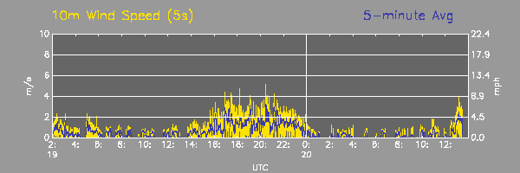
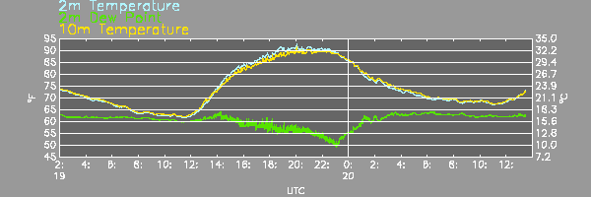
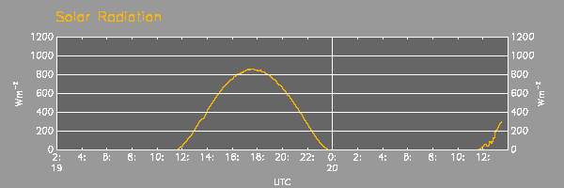
Fluctuating wind
(turbulent bursts)
We then take the natural log of each side (i.e., ln e_{s} = ln A - B/T), utilize the approximate formula e_{s}=pr_{vs}/ε, and finally solve for T (which is T_{d} in this case). The approximate analytical expression for Td in terms of rv and p can then be expressed as

$T_{d}=T_{d}(r_{\text{vs}},p)=\frac{B}{\text{ln}\left(\frac{Aε}{r_{v}p}\right)}$ (6.2)

This relation explicitly shows that T_{d} is a function of r_{v} and p. Given values of rv and p, one can graphically determine Td on a skew-T as shown in Fig. 6.2 below. As an extension of this problem, we will consider fog formation in Section 6.4.1.
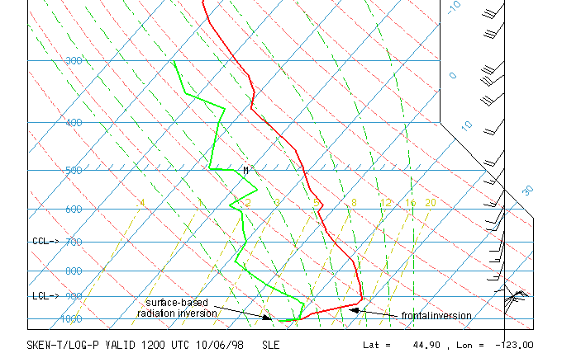
Fig. 6.1. Sounding of T and T_{d} plotted on a skew-T, ln p diagram. The sounding was acquired from a radiosonde released at 1200 UTC, 6 October 1998, from Salem, Oregon. The very lowest levels are saturated since T and T_{d} are nearly coincident. Fog was reported in the area

Figure 6.2. Illustration of processes by which saturation may be achieved in the atmosphere. This skew-T diagram also illustrates the graphical method to determine Td, T_{w} and Tsp. Illustration of Normand's rule.

Now we will investigate the relationship between T_{d} and relative humidity f. Our goal here is to determine how relative changes in T_{d} are related to relative changes in f. [The following is extracted from Iribarne and Godson 1973]. Again, we utilize the formula
$$e≃\frac{{\text{pr}}_{v}}{ε}$$
and take the log differential to get

dlne = dlnp + dlnr_{v}. (6.3)

We combine (6.3) with the Clausius-Clapeyron equation, written below in differential form

$\frac{d\text{ln}e}{{\text{dT}}_{d}}=\frac{L_{\text{vl}}}{R_{v}T_{d^{2}}}$ (here e = e_{s} since T=T_{d}) (6.4)

to obtain, after some rearranging, the following:

${\text{dT}}_{d}=\frac{R_{v}T_{d^{2}}}{L_{\text{vl}}}(d\text{ln}p+d\text{ln}r_{v})$

Dividing both sides by T_{d} yields

$d\text{ln}T_{d}=\frac{{\text{dT}}_{d}}{T_{d}}=\frac{R_{v}T_{d}}{L_{\text{vl}}}(d\text{ln}p+d\text{ln}r_{v})≈5x{\text{10}}^{−2}(d\text{ln}p+d\text{ln}r_{v})$,

where the latter approximate equality is obtained from the term [R_{v}T_{d}/L_{vl}] by assuming T_{d}=270 K, L_{vl}=2.5x10⁶ J kg⁻¹, and R_{v}= 461 J kg⁻¹ K⁻¹ . This result indicates that the relative increase in T_{d} (here, relative refers to the ratio dT_{d}/T_{d}, or an incremental change relative to the total value) is about 5% the sum of the relative increases in p and r_{v}. We now integrate the C-C eq. (6.4) above to get

$\text{ln}\left(\frac{e_{s}}{e}\right)\text{=-}\text{ln}f=\frac{1}{R_{v}}\int{\frac{L_{\text{vl}}}{T^{2}}}\text{dT}@\frac{L_{\text{vl}}}{R_{v}}\frac{T−T_{d}}{{\text{TT}}_{d}}\text{.}$

We then solve for so-called dewpoint depression (T-T_{d}), use decimal logarithms [using the definition that log₁₀ x = ln x / ln 10 = 0.43429 ln x], and subsitute for constants to get

(T-T_{d}) = 4.25x10⁻⁴ T⋅T_{d}(-log₁₀f)

For T⋅T_{d} =290² (i.e., assuming T = 290 K and T_{d} = 290 K) we have

T-T_{d} ≈ 35(-log₁₀f) (6.5)

Then for f=0.8, (T-T_{d}) ≅ 3.5 °C = 6.3 °F. Thus, a change of (T-T_{d}) every 1 °F translates to a change in f of about 3.2%. This verifies my general rule of thumb that, for f>0.8, the dewpoint depression, T-T_{d}, is 1 °F for every 3% change in f, for f < 100%. For example, if T=75 °F and f=0.88, then T_{d}≅71 °F.

Observational question: What is the range of T_{d} in the atmosphere? What is the upper limit of T_{d}, and where would this most likely occur?

b) Isobaric wet-bulb temperature (Tiw)
We will consider the isobaric wet-bulb temperature T_{iw} here – there is also an adiabatic wet-bulb temperature, T_{aw}. The wet-bulb temperature is achieved via the process of evaporation. Practical examples of T_{iw} are evaporation of rain and the evaporation of the wet bulb wick on the sling psychrometer, a device which measures the dry and wet-bulb temperatures. While the process is isobaric (ideally), the parcel gains rv at the expense of a decrease in T. Assuming that a parcel of unit mass (1 kg) contains rv of water vapor, we can write from the First Law (p=const)

dq = cpd(1+0.887rv)dT = cpmdT [cp=cpd]

The heat loss from evaporation (including a mass rv of water vapor) is

(1+rv)dq = -Llvdrv

Equating the two expressions above gives

cpddT = -Llvdrv[1/(1+rv)][1/(1+0.9rv)] ≅ -Llvdrv(1-1.9rv)
c_{p}dT ≅ -Llvdrv (within ~2%, since rv ~ 0.01) (6.7)

Assuming that Llv and cp are constant (which is a good assumption since the temperature reduction ΔT=T-T_{iw} associated with evaporation is typically <10 K) we can integrate the above to get the wet-bulb depression [note limits of integration here]

T-Tiw = (Lvl/cp)(rvs(Tiw,p) - rv). [note the limits of integration]

Introduction of the Clausius-Clapeyron formula (5.5) [e_{s}(T) = e^{-B/T}] yields an iterative formula for Tiw:

Tiw = T - (Llv/cp)[(ε/p)Ae-B/T^{iw} - rv], (6.8a)

where T and rv are the initial parcel values.

This provides a relation between vapor pressure (e) and the wet bulb depression, (T-T_{iw}):

$e=e_{s}(T_{\text{iw}})−\frac{{\text{pc}}_{\text{pd}}}{{εL}_{\text{vl}}}(T−T_{\text{iw}})$ (6.8b)

The factor $\frac{{\text{pc}}_{\text{pd}}}{{εL}_{\text{vl}}}$ in the above equation is defined as the psychrometric constant (which varies with both p and T). Its value at sealevel is about 0.65 mb/K. In Eq. (6.8b), T is usually referred to as the dry bulb temperature, and T_{iw} is the wet-bulb temperature.

Discuss the sling psychrometer and psychrometric tables.

(Insert psychometric equation development here (Bohren and Albrecht, pp 282-284).

c) Isobarid equivalent temperature (T_{ie})
This is the temperature achieved via isobaric (p=const) condensation (latent heating) of all water vapor. T_{ie} is a fictitious temperature – there is no atmospheric process that is associated with it. (In fact Tsonis notes that T_{ie} is the reverse of an irreversible process associated with T_{iw}.) Thus, this is also referred to as the isobaric equivalent temperature (T_{ie}). This process is similar (but opposite) to that of the isobaric wet-bulb temperature, T_{iw}, so the same equation applies. In this case, integration of (6.7) gives

$\int_{T}^{T_{\text{ie}}}{\text{dT}}=\frac{L_{\text{vl}}}{c_{p}}\int_{r_{v}}^{0}{{\text{dr}}_{v}}$

or

Tie = T + Llvrv/cp. (6.9)

How does the isobaric equivalent temperature differ from the adiabatic equivalent temperature? What is the relation between adiabatic temperature and adiabatic equivlanet potential temperature?

[Brief discussion here.]

T_{ie} and T_{iw} are related by Eq. (6.7) and represent the respective maximum and minimum temperatures that an air parcel may attain via the isenthalpic (adiabatic and isobaric) process.

d) Saturation point temperature (Tsp).
This is also called the "isentropic condensation temperature" (Tc) as defined by Bolton (1980), or the more classical temperature of the lifting condensation level (Tlcl). T_{sp} is achieved via adiabatic lifting (cooling by expansion). The value of Tsp is easily found graphically on a skew-T diagram (see Fig. 6.2). Recall that the adiabatic equation can be derived from the First Law and equation of state to get

cpdT = RdT(dp/p).

Also recall that the integrated form is Poisson's equation

(T/To) = (p/po)κ (6.10)

We now note that Tsp = Td(rv,psp). Substitution of (6.2), the expression for T_{d}, into (6.10) gives an iterative formula of the form (derivation given in Rogers and Yau 1989)

$T_{\text{sp}}=\frac{B}{\text{ln}\left[\left(\frac{Aε}{r_{v}p_{0}}\right){\left(\frac{T_{0}}{T_{\text{sp}}}\right)}^{1/κ}\right]}$ (6.11)

More accurate (and explicit) empirical expressions are given by Eq. (21) in Bolton (1980):

$T_{\text{sp}}=\frac{\text{2840}}{3\text{.}5\text{ln}T−\text{ln}e−4\text{.}\text{805}}+\text{55}\text{.}$ (6.12a)
$T_{\text{sp}}=\frac{1}{\frac{1}{T−\text{55}}−\frac{\text{ln}(f/{\text{100}})}{\text{2840}}}+\text{55}$
(6.12b)

For these two formulations, Tsp is in °C, T in deg K, f in %, and e in mb. The graphical method of determining T_{sp} is known as Normand’s Rule, illustrated in Fig. 6.2. (To be clarified in class.)

Adiabatic expansion and condensation
We now ask the question: Does adiabatic expansion necessarily produce condensation?
Before answering this, let’s consider the following example hypothetical problem:

Example:
Condensation of water can occur in updrafts because the saturation mixing ratio decreases in adiabatic ascent. This property of water can be attributed to the high value of latent heat of condensation. It has long been speculated that there may be trace gases which, because of low values of L, would condense in downdrafts (Bohrens 1986). Show that the criterion that must be satisfied if vapor is to condense in downdrafts (adiabatic compression) is
L < c_{p}T/ε.
Solution:
From the definition of f=e/e_{s}, we can write dlnf/dz = dlne/dz – dlne_{s}/dz. Since e = r_{v}p/ε (and mixing ratio r_{v} is constant), dlne = dlnp. Then dlnf/dz = dlnp/dz – (dlne_{s}/dT)(dT/dz). We now use the C-C equation dlne_{s}/dT = L/(R_{v}T²) and insert into the previous equation: df/dz = p⁻¹dp/dz – (L/R_{v}T²)dT/dz. Recall that the dry adiabatic lapse rate (dT/dz here) is dT/dz = -g/c_{p}. Also, p⁻¹dp/dz = p⁻¹g/α = g/R_{d}T. Substitution of these into the previous yield dlnf/dz = g/R_{d}T – gL/(c_{p}R_{v}T²) = g/(R_{d}T)[1-LR_{d}/(c_{p}R_{v}T)] = g/(R_{d}T)[1-(Lε/c_{p}T)]. Thus, if f increases with decreasing height, the term in brackets should be > zero, i.e., 1 – Lε/C_{p}T > 0.
Rewriting, L < c_{p}T/ε is the criterion for saturation upon descent. For the atmosphere, c_{p} = 1005, T = 290, and ε = 0.622, we have L < 4.7x10⁵ J kg⁻¹. This is clearly not satisfied for water, but is possible for some volatile substances.

Recall that we are considering saturation by adiabatic expansion:
adiabatic expansion → cooing → tendency towards saturation
Taking the log differential of relative humidity, f=e/e_{s} we get
dln f = dlne – dlne_{s}
Note that the ratio e/p = N_{v} is constant during ascent, which is equivalent to saying that the mixing ratio r_{v} = εe/p is conserved. Furthermore, from Poisson’s equation, Tp^{−κ} is constant (i.e., θ is conserved). Since e = N_{v}p, then
Te^{−κ} = N_{v}^{−κ} x const = new const
or T = c₁e^{κ}

Taking the log differential of the above, we obtain
$d\text{ln}e_{s}=\frac{L_{\text{vl}}}{R_{v}T^{2}}\text{dT}$ dlnT = κdlne (or dlne = κ⁻¹dlnT).
From the C-C eq.
and f = e/e_{s}, we can write

dlnf = dln(e/e_{s}) = dlne – dlne_{s}
$d\text{ln}f=κ^{−1}d\text{ln}T−\frac{L_{\text{vl}}}{R_{v}T^{2}}\text{dT}$$\frac{\text{df}}{\text{dT}}=\frac{f}{T}\left(κ^{−1}−\frac{L_{\text{vl}}}{R_{v}T}\right)=\frac{f}{T}\left(\frac{c_{p}T−{εL}_{\text{vl}}}{R_{v}T}\right)$where the first term on the RHS is the change due to a decrease in p (and e), and the second term represents the change in f from a decrease in T and e_{s}(T). These terms have opposite signs; therefore, adiabatic expansion could increase or decrease f. To clarify this point, we can write the above to represent the slope, df/dT, the sign of which we want to determine:

This equation shows that df/dT < 0 (i.e., f increases when T decreases) when the condition
c_{p}T < εL_{vl} or T < εL_{vl}/c_{p} ≅ 1500 K.

Determination of cloud base from the dew point depression, (T-T_{d})
There is a practical application that is closely assocated with T_{sp}. In this application we will derive a relationship between the height of T_{sp} and the surface dewpoint depression, T-T_{d}. We assume that a surface parcel rises (adiabatically) until condenstion occurs (this defines cloud base). In reality, r_{v} typically exhibits a negative vertical gradient, because the source of rv is surface evaporation, and the sink is mixing from above. The relation that we derive will provide a useful formula for estimation of the base of cumulus clouds, given a measurement of (T-T_{d}) at the surface.
We know that the lapse rate for a subsaturated parcel is given by the dry adiabatic lapse rate, approximately 10 K km⁻¹. To estimate the height at which condensation occurs, we need to examine the variation of T_{d} along a dry adiabat. This is given by the C-C eq.
${\text{dT}}_{d}=\frac{R_{v}T_{d^{2}}}{L_{\text{vl}}}d\text{ln}e$Using the relation dlnT = κdlne (κ = R_{d}/c_{pd} from p. 7) we can rewrite the above as
${\text{dT}}_{d}≃\frac{R_{v}T_{d^{2}}}{{κL}_{\text{vl}}}\frac{\text{dT}}{T}=\frac{c_{p}T_{d^{2}}}{{εL}_{\text{vl}}}\frac{\text{dT}}{T}$
For T ≈ T_{d} ≈ 273 K, and using finite differences (and the implied assumptions), we obtain the approximate relation
ΔT_{d} ≈ (1/6)ΔT,
i.e., the magnitude of the T_{d} decrease is about one sixth that of the adiabatic lapse rate for a parcel undergoing adiabatic ascent. This is shown in Fig. 6.3 on a skew-T schematic.
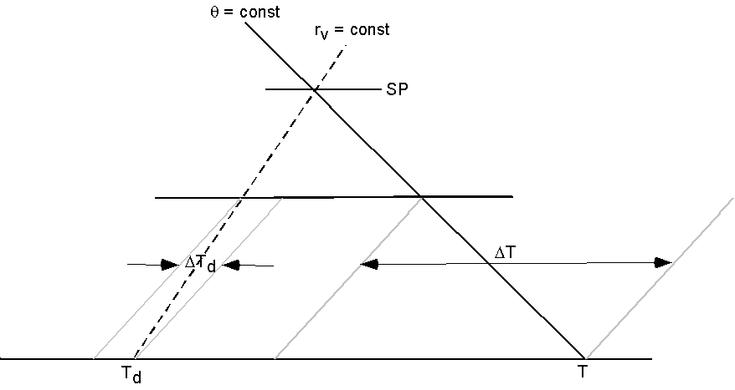
Fig. 6.3. Illustration of the relation between decreases in T and Td during adiabatic lifting of a subsaturated parcel.
6.2 The reversible saturated adiabatic process and related items

6.2.1 Derivation of the reversible saturated adiabatic lapse rate

We have considered a related topic in the derivation of the pseudo adiabatic lapse rate and θe. In Chap. 3 (notes), we considered a preliminary form of the pseudo-adiabatic lapse rate, Eq. (3.21), reproduced here:

${\left(\frac{\text{dT}}{\text{dz}}\right)}_{s}≡Γ_{s}=\frac{Γ_{d}}{1+\frac{L_{\text{vl}}}{c_{p}}\frac{{\text{dr}}_{\text{vs}}}{\text{dT}}}$ (3.21)

The term in the denominator required the Clausius-Clapeyron Equation to provide an expression for dr_{vs}/dT. This term is related to the magnitude of latent heating within the saturated parcel. As shown in Fig. 6.4, the local lapse rate along the saturated adiabat in the lower right side (warm, high water vapor content) is relatively low, while at low pressure and cold temperature (upper part) the local value of the saturated adiabat approaches that of the dry adiabat.

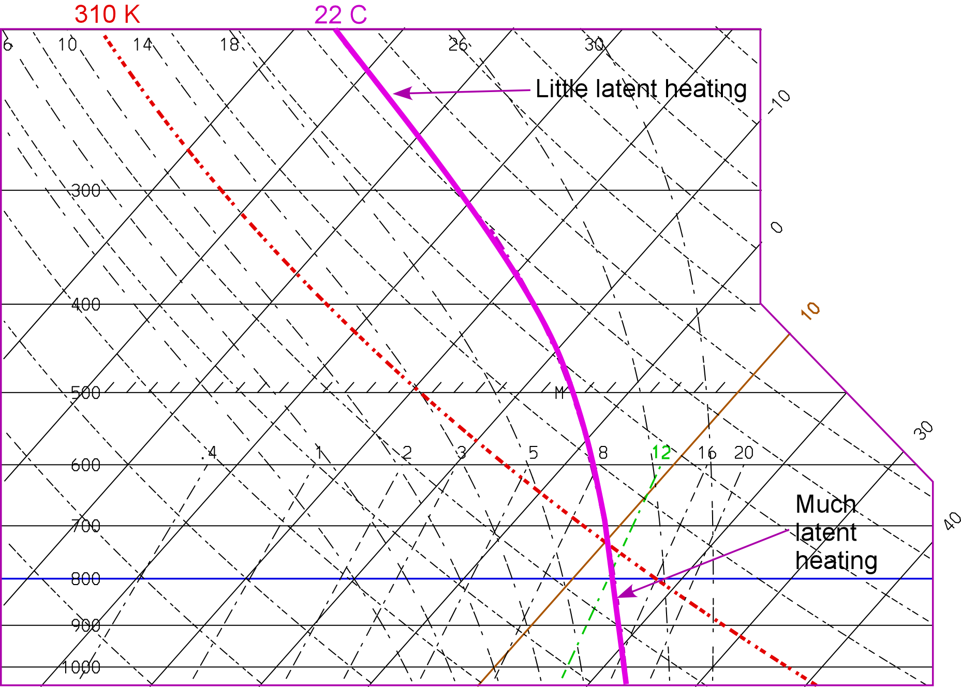

Figure 6.3. Variation in the local value of dT/dz along the saturated adiabat (bold solid line) on the Skew-T, ln p diagram.

We will now consider the behavior of the saturated adiabat in more detail.

One can make two limiting assumptions regarding the condensed water:
- It is carried along with the parcel.
- It immediately leaves the parcel (by removal – called sedimentation – from the precipitation process).

In reality, the clouds in the atmosphere are somewhere in between these two extremes. The latter process is the pseudoadiabtic process and simplifies matters since one need not consider the heat content of the condensed water (condensate) that is carried with the parcel. This process (and lapse rate) was considered in Section 3.11.3, Eq. 3.21 (above). We also note that the psuedoadiabtic process is irreversible, whereas the saturated adiabatic process (i) is reversible. It turns out that the lapse rate defined by each is nearly the same.

The starting point differential equation (First Law) for the reversible process has an extra term that expresses that amount of heat contained by the condensate:
$c_{w}r_{a}\text{dT}−d(L_{\text{vl}}r_{\text{vs}})=\left[c_{\text{pd}}(1−r_{\text{vs}})+c_{\text{vv}}r_{\text{vs}}\right]\text{dT}−{\text{dp}}/ρ$ (6.11)

where r_{a} is the weight of condensed water per gram of air (this will be referred as the adiabatic liquid water content). Our starting point for the pseudo-adiabatic lapse rate was a simplified form of (6.11), already having the approximation L_{vl}=const. We also ignored the contribution of enthalpy from moist air, the second term within the brackets on the RHS of (6.11). The key term here is the first term on the LHS, c_{w}r_{a}dT, the heat stored by the condensate.

Introducing the First Law (p=ρR_{d}T) and then expanding terms in (6.11) yields

$$c_{w}r_{a}\text{dT}−L_{\text{vl}}{\text{dr}}_{\text{vs}}−r_{\text{vs}}{\text{dL}}_{\text{vl}}=c_{\text{pd}}\text{dT}+r_{\text{vs}}(c_{\text{vv}}−c_{\text{pd}})\text{dT}−R_{d}T\frac{\text{dp}}{p}$$

Refer to the handout, copied from Chapter 6 of the book Atmospheric Thermodynamics (Bohren and Albrecht (1998) for details of the derivation.

The final form (taken from Iribarne and Godson, 1973) is

$Γ_{s−\text{rev}}=Γ_{d}\frac{\frac{p}{p−e_{s}}\left[1+\left(\frac{L_{\text{vl}}}{R_{m}T}−0\text{.}\text{61}\right)r_{\text{vs}}\right]}{1+\frac{c_{\text{pv}}r_{\text{vs}}+c_{w}(r_{\text{tw}}−r_{\text{vs}})}{c_{\text{pd}}}+\frac{L_{{\text{vl}}^{2}}r_{\text{vs}}(ε+r_{\text{vs}})}{c_{\text{pd}}R_{d}T^{2}}}$ A1

where R_{m} = R_{d}(1+0.61r_{v}), the total water mixing ration r_{tw} = r_{vs} + r_{a} (r_{a} is the adiabatic mixing ratio of condensed water), and Γ_{d} = g/c_{pd}.

The formula for the pseudoadiabatic lapse rate is (assuming that no liquid water remains with the parcel, i.e., r_{tw} - r_{vs} = r_{a} = 0 in the above equation).

$Γ_{s−\text{pseudo}}=Γ_{d}\frac{\frac{p}{p−e_{s}}\left[1+\left(\frac{L_{\text{vl}}}{R_{m}T}−0\text{.}\text{61}\right)r_{\text{vs}}\right]}{1+\frac{c_{\text{pv}}r_{\text{vs}}}{c_{\text{pd}}}+\frac{L_{{\text{vl}}^{2}}r_{\text{vs}}(ε+r_{\text{vs}})}{c_{\text{pd}}R_{d}T^{2}}}$ A2

One can also make the following approximations in Eq. A2:

$\frac{p}{p−e_{s}}≈1$, $\left(\frac{L_{\text{vl}}}{R_{m}T}−0\text{.}\text{61}\right)≈\frac{L_{\text{vl}}}{R_{m}T}≈8\text{.}7$, $1+\frac{c_{\text{pv}}r_{\text{vs}}}{c_{\text{pd}}}≈1$

to get the approximate form for the pseudoadiabatic lapse rate (also letting R_{d} ≈ R_{m}):

$Γ_{s−\text{approx}}=Γ_{d}\frac{\frac{L_{\text{vl}}r_{\text{vs}}}{R_{d}T}}{1+\frac{{εL}_{{\text{vl}}^{2}}r_{\text{vs}}}{c_{\text{pd}}R_{d}T^{2}}}$ A3

This is an approximation for the local slope and should never be used be used for calculations requiring an accurate parcel T, since the errors will accumulate to unacceptably high values in the integration.

Example (Iribarne and Godson, p. 158):

This will illustrate the errors for a saturated parcel with the following values:

T = 17 °C, p = 1000 mb, e_{s} = 19.4 mb, r_{vs} = 0.0123 kg kg⁻¹. Also assume that r_{a} = 0.004 kg kg⁻¹.

Equation A1, A2 and A3 yield the following values:

Γ_{s-rev} = 4.40 K km⁻¹

Γ_{s-pseudo} = 4.42 K km⁻¹

Γ_{s-approx} = 4.50 K km⁻¹

These differences are appreciable. Another example take from Emanuel (1994, p. 133) illustrates how the differences can accumulate, as shown below in Table A1. Also refer to Bohren and Albrecht, Fig. 6.5, reproduced below.

Table A1. Parcel temperature obtained from s-rev (Eq. A1) and s-pseudo (Eq. A2), for a saturated parcel ascending with initial conditions p = 950 mb, T = 25 C (very wet)
p (mb) | T_{s-rev} (K) | T_{s-pseudo} (K) | T_{s-rev}-T_{s-pseudo} (K) | T_{ρ-rev} – T_{ρ-pseuo}
950 | 298.15 | 298.15 | 0 | 0
800 | 292.36 | 292.35 | 0.01 | -1.04
700 | 287.77 | 287.73 | 0.04 | -1.75
600 | 282.32 | 282.22 | 0.10 | -2.44
500 | 275.59 | 275.36 | 0.23 | -3.07
400 | 266.78 | 266.27 | 0.51 | -3.51
300 | 254.10 | 252.90 | 1.21 | -3.39
200 | 233.30 | 230.32 | 2.98 | -1.76
100 | 195.77 | 189.96 | 5.81 | 1.70

The right-most column in Table A1 is the difference between density temperatures (T_{ρ}) for the two processes. Density temperature is the temperature dry air would have to yield the same density as moist, cloudy air (i.e., virtual temperature including water vapor and cloud condensate – more on this later).

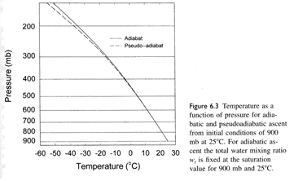
Figure 6.5. Figure taken from Bohren and Albrecht (1998)

Notes:

- Perhaps the most common application involves the calculation of convective available potential energy, which requires an accurate calculation of the parcel T during saturated ascent. CAPE is discussed in Chap. 8 of the Notes and pages 139 and 153 of Tsonis.
- If we recognize that θ_{e} is conserved along a saturated adiabat, then a numerical calculation of T_{s} should conserve θ_{e}. This can be used as a check for the accuracy of the T_{s} calculation.
- After having considered the differences between the reversible and pseudo saturated adiabatic processes, we can ask the question “Which is the best to use?” We cannot fully answer this question until we have a greater understanding of cloud physics and microphysical structure of clouds.

Effects of freezing. If we use the latent heat of deposition, then a difference will exist between Γ_{s} for condenstation and deposition. This difference is shown in the figure below.

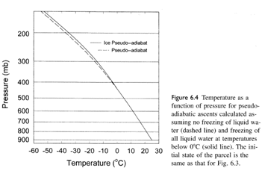

Figure 6.6. Figure taken from Bohren and Albrecht (1998)

Figure 6.7 defines the relative orientation or slope (magnitude) of each on a skew-T diagram.

The magnitude of the saturated adiabatic lapse rate is slightly less than that of the pseudoadiabatic lapse rate. Similarly, the magnitude of the dry adiabatic lapse rate (for dry air) is slightly greater than its counterpart for moist (rv nonzero) air, since the effective cp is larger [cp(1+0.887rv)]. More specifically, we can write the lapse rate for moist air as

$Γ_{m}=\frac{g}{c_{\text{pm}}}=\frac{g}{c_{\text{pd}}(1+0\text{.}\text{87}r_{v})}=\frac{Γ_{d}}{1+0\text{.}\text{87}r_{v}}≃Γ_{d}(1−0\text{.}\text{87}r_{v})$ (6.12)

The ratio of the dry to moist adiabatic lapse rates is

$$\frac{Γ_{m}}{Γ_{d}}=\frac{g/{c_{\text{pd}}}}{g/{c_{\text{pd}}}(1+0\text{.}\text{87}r_{v})}=\frac{1}{1+0\text{.}\text{87}r_{v}}≃1−0\text{.}\text{87}r_{v}$$

For a mixing ratio of 20 g kg⁻¹, this ratio is 0.983. Thus, a difference up to ~2%, or 0.2 K km⁻¹, is possible. This is potentially significant!

Figure 6.7. Relative orientation of fundamental lines on a skew-T, ln p diagram.

6.2.2 Adiabatic liquid water content

Adiabatic liquid water content is defined as the amount of water condensed, during the reversible (saturated) adiabatic process, during ascent above a parcel's level of condensation or saturation point (SP). This value has relevance to the onset and rate of growth of precipitation by the collection process (to be considered later under our study of cloud physics). In cumulus clouds, the ratio of actual measured cloud water mixing ratio (rc) to the adiabatic mixing ratio (r_{ca}) is typically a small fraction, i.e., r_{c}/r_{ca} < 1. This is a result of (i) mixing between the cloud and its environment, and (ii) removal of r_{c} by the precipitation process (large particles collect the smaller cloud droplets) in the case of precipitating clouds. There are instances of nearly adiabatic liquid water in the lower regions of vigorous nonprecipitating cumulus convection and in thunderstorms. [What factor(s) produce a ratio r_{c}/r_{ca} > 1?] The adiabatic liquid water content, χ, is usually expressed in g m-3 by multiplying r_{ca} by density ρ. Typical values of r_{c} in clouds are in the range 0.5 to 3 g m-3. During saturated adiabatic ascent, a reduction in water vapor (-drvs) is a gain in cloud condensate (rc), such that the total water is conserved. Thus,

dχ = ρdrca = -ρdr_{vs}. (6.12)

The value of χ can be derived from the adiabatic equation derived previously, and can be related to the difference between the dry and saturated adiabatic lapse rates (this is a homework problem). χ is easily found graphically as shown in the figure below. Its value requires knowledge of cloud base (saturation point) conditions (rvs,p) and is computed as

χ = ρ_{m} [rvs(Tsat,p)θ_{e=const} - rvs(T_{sp},p_{sp})],

where the temperature Tsat is evaluated along a saturated adiabat (line of constant θ_{e}).

Figure 6.4. Graphical determination of adiabatic liquid water content.

6.2.3 Relation between θ_{e} and θ_{w}

The calculation for θ_{e} was presented in increasing levels of accuracy in this chapter, and in Chap. 3. One can determine θ_{w} if T_{w} is known, and then calculate the temperature of the parcel after it descends along a saturated adiabat to 1000 mb. In a sense, this process is the opposite of that by which θ_{e} is achieved, where the parcel ascends along a saturated adiabat until all water vapor is removed by condensation. This numerical computation of either of these processes would require use of Eq. A1 or Eq. A2.

The derivation of θ_{w} begins with the assumption that the parcel is at its saturation point.

We start with the differential equation

$c_{p}d\text{ln}θ=d\left(\frac{L_{\text{vl}}r_{v}}{T}\right)$ (A4)

and integrate as follows

$$c_{p}\int_{θ}^{θ_{w}}{d\text{ln}θ}=\int_{r_{v}}^{r_{\text{vs}}(θ_{w})}{d\left(\frac{L_{\text{vl}}r_{v}}{T}\right)}$$

Integration yields

$θ_{w}=θ\text{exp}\left(\frac{L_{\text{vl}}}{c_{p}}\left(\frac{r_{v}}{T_{\text{sp}}}−\frac{r_{\text{vs}}(θ_{w})}{θ_{w}}\right)\right)$ (A5)

This is a transcendental equation that requires interation. Since the exponent term is less than ~0.2, the (A5) can be approximated as

$θ_{w}≈θ+\left(\frac{L_{\text{vl}}}{c_{p}}\left(\frac{θ}{T_{\text{sp}}}r_{v}−\frac{θ}{θ_{w}}r_{\text{vs}}(θ_{w}\right)\right)$ (A6)

If we can further assume that the ratios θ/T_{sp} and θ/θ_{w} are near unity, then further approximation provides the following:

$θ_{w}≈θ+\left(\frac{L_{\text{vl}}}{c_{p}}\left(r_{v}−r_{\text{vs}}(θ_{w}\right)\right)=θ_{e}−\frac{L_{\text{vl}}}{c_{p}}r_{\text{vs}}(θ_{w})$ (A7)

which establishes a relationship between θ_{w} and θ_{e}, both of which are conserved for saturated adiabatic processes.

6.2.4 The wet equivalent potential temperture (θq)

See RY, pp. 25-26 for derivation. This parameter is conserved for saturated processes, and hence is useful in analyzing mixing processes in clouds. More on applications of this will be considered later.

6.4 Example computations using the skew-T diagram.

a) Given: p=1000, T=20 oC, Td=10 oC (variables commonly reported)
Find: rv, f, θ, Tv, Tsp, Te, Tae, θe, Tw, θw, χ(at 50 kPa)

6.5 Summary

The figure below (i) summarizes the relative magnitudes of the basic and derived thermodynamic variables that we have considered to this point and (ii) illustrates the graphical determination of some of these. We can note that the non-potential temperatures exhibit the inequality:

Tsp < Td < Tw < T < Tv < Tie < Tae.

Finally, the conservative properties of the various thermodynamic variables are indicated in the table below.

Table 6.2. Conservative properties of several thermodynamic parameters (after Iribarne and Godson 1973).

Variable Process:
Isobaric Isobaric Non-saturated Saturated
warming or evaporation or adiabatic adiabatic
cooling (without condensation expansion or expansion or
condensation or compression compression
evaporation) (reversible)
(e.g., radiation) (e.g., rainfall)
_____________________________________________________________________________________
f NC (not conserved) NC NC C
e or Td C (conserved) NC NC NC
rv C NC C NC
Tw or Tae NC C NC NC
θ NC NC C NC
θe or θw NC C C C
Tsp NC NC C C
T NC NC NC NC
_____________________________________________________________________________________

Figure 6.5. Summary of temperature/humidity parameters, plotted on a tephigram. Line orientations are similar for a skew-T, ln p diagram. (After Iribarne and Godson, 1973)

Problems -- Chap. 6

1) A chinook wind is taking place on the leeward side of a mountain in New Mexico. The air within this hot, dry wind system has the following parameters: p = 1000 mb, T = 38 °C, r_{v} = 4 g kg⁻¹. (a) Could this air be the same as that at the 1000 mb level on the windward side of the mountains, where the air has the following parameters: T = 21.5 °C, r_{v} = 10 g kg⁻¹? (b) Could it be the same as that at the 800 mb levels where T = 5 °C and r_{v} = 5 g kg⁻¹? State reasons for your answers, and also use a skew-T diagram to support your answers. [Hint: Consider what variables are conserved for this process.]

2) What is the maximum wet-bulb depression, T-T_{w}, possible for T = 0 °C and p = 100 kPa?

3) With regard to the equation that precedes Eq. (6.5), and the associated discussion, compare and discuss the relation between (T-T_{d}) and Δf for the following extreme values of T and T_{d}.
a) T = 310 K, Td = 280 K
b) T = 250 K, Td = 248 K
Determine the actual value of f for cases (a) and (b), and the rule of thumb relation between a ΔT of 1 °F and the corresponding Δf.

4) Show that the plot of e_{s} vs. T has positive curvature for temperatures normally encountered in the atmosphere. (Recall that the mathematical definition of curvature is defined second derivative of the function.)

5) An air parcel has the following thermodynamic parameters: T = 25 °C, f = 0.75, p = 90 kPa. When possible, calculate the following as accurately as possible (when calculation is not readily done, find the value graphically, but also indicate, with appropriate equation(s) how you would compute precise values):
- vapor pressure, e
- density of water vapor, ρ_{v}
- water vapor mixing ratio, r_{v}
- specific humidity, q_{v}
- density of dry air, ρ_{d}
- virtual temperature, T_{v}
- isobaric wet-bulb temperature, T_{iw}
- adiabatic wet-bulb temperature, T_{aw}
- saturation point temperature, T_{sp}
- potential temperature, θ
- isobaric equivalent temperature, T_{ie}
- adiabatic equivalent temperature, T_{ae},
- equivalent potential temperature, θ_{e}
- wet-bulb potential temperature, θ_{w}
- adiabatic liquid water content at 500 mb, χ

"Derive an expression for the rate of increase of relative humidity with respect to height for a well-mixed unsaturated layer. Use this expression to evaluate the depth of layer required so that the top is just saturated given that the base has a relative humidity RH of 30%. What does this tell you about the likely outcome of mixing in the troposphere (where RH is typically 30% or more)?"
Some useful tables for moist thermodynamics:

Table 6.x. Saturation vapor pressure and mixing ratio values over plane water and ice surfaces (from List, 1949, based on Goff-Gratch formula)

T (°C) | e_{sw} (mb) | e_{si} (mb) | r_{vs} (g kg⁻¹) | r_{vsi} (g kg⁻¹)
-70 |  | 0.0026 |  | 0.0016
-60 |  | 0.011 |  | 0.0067
-50 | 0.064 | 0.039 | 0.038 | 0.0246
-40 | 0.189 | 0.128 | 0.113 | 0.080
-30 | 0.509 | 0.380 | 0.303 | 0.238
-25 | 0.807 | 0.632 | 0.481 | 0.400
-20 | 1.254 | 1.032 | 0.747 | 0.646
-15 | 1.912 | 1.652 | 1.14 | 1.034
-10 | 2.863 | 2.597 | 1.71 | 1.627
-5 | 4.215 | 4.015 | 2.52 | 2.518
0 | 6.108 | 6.107 | 3.66 | 3.839
5 | 8.719 |  | 5.23
10 | 12.272 |  | 7.39
15 | 17.044 |  | 10.31
20 | 23.373 |  | 14.23
25 | 31.671 |  | 19.44
30 | 42.430 |  | 26.32
35 | 56.236 |  | 35.38
40 | 73.777 |  | 47.27
45 | 95.855 |  | 62.86

log₁₀e_{sw} = -7.90298(T_{s}/T -1) + 5.02808 log₁₀(T_{s}/T) - 1.3816x10⁻⁷(10^{11.344(1-T/T}s⁾ -1)
+8.1328x10⁻³(10 ^{-3.49149 T}s^{/T-1} - 1) + log₁₀e_{ws}

where Ts = 373.15 K, To = 273.15 K
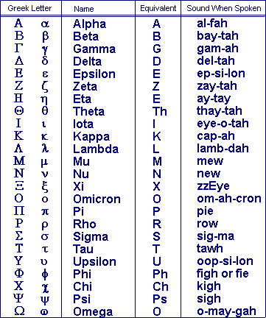

The saturation point temperature is also known as the temperature of the lifting condensation level (T_{lcl}) or the isentropic condensation temperature (T_{c}).

