2 February, 2022

Vol. 32, No. 10

For Additional Information:
Dr. John Christy, (256) 961-7763
christy@nsstc.uah.edu
Dr. Roy Spencer, (256) 961-7960
spencer@nsstc.uah.edu

Global Temperature Report: January 2022

Global climate trend since Dec. 1 1978: +0.13 C per decade

January Temperatures (preliminary)

Global composite temp.: +0.03 C (+0.05°F) above seasonal average

Northern Hemisphere: +0.06 C (+0.11 °F) above seasonal average

Southern Hemisphere: +0.00 C (+0.00 °F) equal to seasonal average

Tropics: -0.24 C (-0.43 °F) below seasonal average

December Temperatures (final)

Global composite temp.: +0.21 C (+0.38°F) above seasonal average

Northern Hemisphere: +0.27 C (+0.49 °F) above seasonal average

Southern Hemisphere: +0.15 C (+0.27 °F) above seasonal average

Tropics: +0.03 C (+0.05 °F) above seasonal average

Notes on data released February 2, 2022 (v6.0, with 1991-2020 reference base)

The global temperature departure from average in January fell from December to what is essentially zero, at +0.03 °C (+0.05 °F). Equatorial cooling associated with the on-going presence of La Niña continued and the tropics are now substantially below the 30-year average at -0.24 °C (-0.43 °F). As is often noted on these reports, the maximum cooling effect of La Niñas usually occurs sometime from February to May. The latest on this La Niña event can be found here.

https://www.cpc.ncep.noaa.gov/products/analysis_monitoring/lanina/enso_evolution-status-fcsts-web.pdf.

The planet’s warmest region, in terms of the monthly departure from average, was over eastern Russia where one grid cell hit +4.6 °C (+8.2 °F) above normal in the Bilibinsky District. The pattern of warm and cold anomalies is related to the influence of the La Niña-induced cooling in the tropics. Other warm areas were experienced in the No. Atlantic and alternating regions in the far southern oceans.

Tukarak Island in the Hudson Bay, Canada, came in with the coldest grid cell and was -3.5°C (-6.3 °F) below average. The cool regions in the tropical Pacific (due to La Niña) led to a pattern that produced cold areas in NE Canada and along the Antarctic coastline of the Western Hemisphere. It was also quite cool over the No. Africa, parts of SE Asia and the subtropical western Pacific.

The large-scale pattern this month favored cool temperature over the eastern half of the conterminous US where the 48-state temperature averaged just below normal at -0.13 °C (-0.23 °F). The upper Mid-West and Northeast were especially cool while the West coast was above average. However, Alaska was a bit warmer than usual overall, influencing the 49-state average to increase slightly to -0.05 °C (-0.09 °F). [We don’t include Hawaii in the US results because its land area is less than that of a satellite grid square, so it would have virtually no impact on the overall national results.]

New Reference Base Jan 2021 and forward. As noted in the Jan 2021 GTR, the situation comes around every 10 years when the reference period or “30-year normal” that we use to calculate the departures is redefined. With that, we have averaged the absolute temperatures over the period 1991-2020, in accordance with the World Meteorological Organization’s guidelines, and use this as the new base period. This allows the anomalies to relate more closely to the experience of the average person, i.e. the climate of the last 30 years. Due to the rising trend of global and regional temperatures, the new normals are a little warmer than before, i.e. the global average temperature for Januaries for 1991-2020 is 0.14 °C warmer than the average for Januaries during 1981-2010. So, the new departures from this now warmer average will appear to be cooler, but this is an artifact of simply applying a new base period. It is important to remember that changes over time periods, such as a trend value or the relative difference of one year to the next, will not change. Think about it this way, all we’ve done is to take the entire time series and shifted it down a little.

To-Do List: There has been a delay in our ability to utilize and merge the new generation of microwave sensors (ATMS) on the NPP and JPSS satellites. As of now, the calibration equations applied by the agency have changed at least twice, so that the data stream contains inhomogeneities which obviously impact the type of measurements we seek. We are hoping this is resolved soon with a dataset that is built with a single, consistent set of calibration equations. In addition, the current non-drifting satellite operated by the Europeans, MetOP-B, has not yet been adjusted or “neutralized” for its seasonal peculiarities related to its unique equatorial crossing time (0930). While these MetOP-B peculiarities do not affect the long-term global trend, they do introduce error within a particular year in specific locations over land.

As part of an ongoing joint project between UAH, NOAA and NASA, Christy and Dr. Roy Spencer, an ESSC principal scientist, use data gathered by advanced microwave sounding units on NOAA, NASA and European satellites to produce temperature readings for almost all regions of the Earth. This includes remote desert, ocean and rain forest areas where reliable climate data are not otherwise available. Drs. Danny Braswell and Rob Junod assist in the preparation of these reports.

The satellite-based instruments measure the temperature of the atmosphere from the surface up to an altitude of about eight kilometers above sea level. Once the monthly temperature data are collected and processed, they are placed in a "public" computer file for immediate access by atmospheric scientists in the U.S. and abroad.

The complete version 6 lower troposphere dataset is available here:

http://www.nsstc.uah.edu/data/msu/v6.0/tlt/uahncdc_lt_6.0.txt

Archived color maps of local temperature anomalies are available on-line at:

http://nsstc.uah.edu/climate/

Neither Christy nor Spencer receives any research support or funding from oil, coal or industrial companies or organizations, or from any private or special interest groups. All of their climate research funding comes from federal and state grants or contracts.

--30—

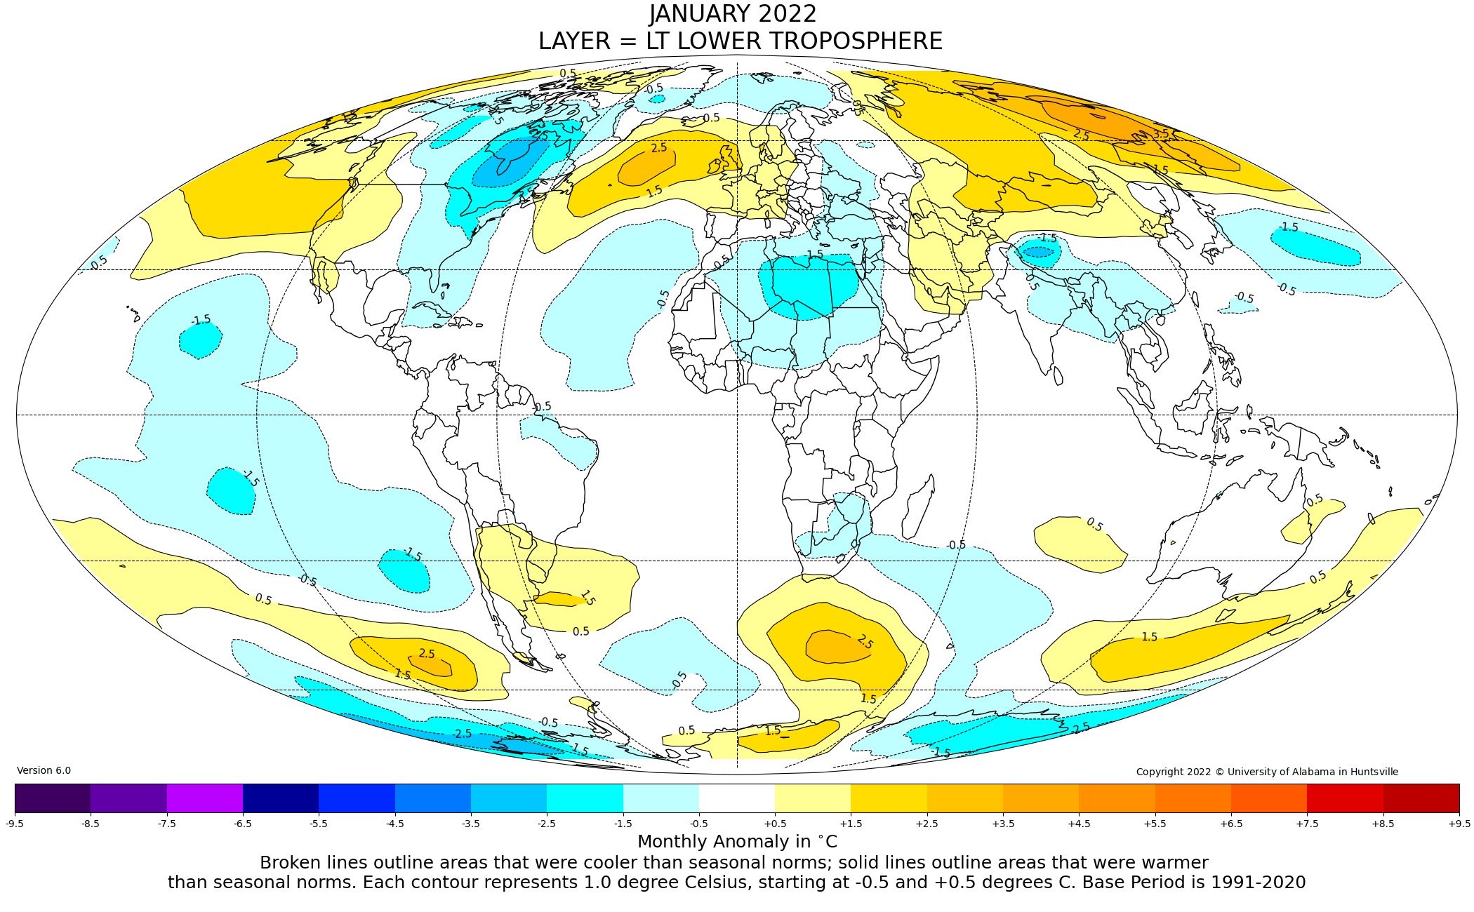
Figure. Lower tropospheric temperature anomalies for January 2022

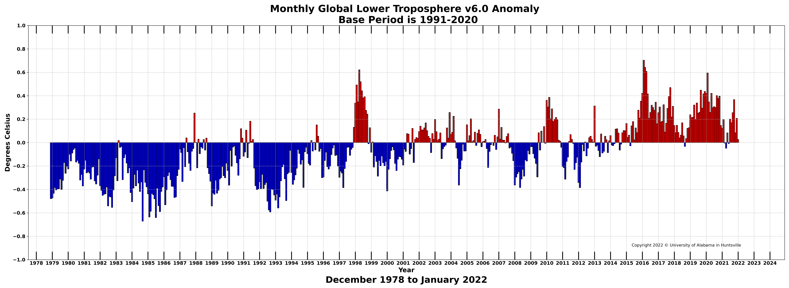

Figure. Bar chart of global monthly lower tropospheric temperature anomalies.

