January 18, 2022

Vol. 32, No. 9

For Additional Information:
Dr. John Christy, (256) 961-7763
christy@nsstc.uah.edu
Dr. Roy Spencer, (256) 961-7960
spencer@nsstc.uah.edu

Global Temperature Report: December 2021 and Annual 2021
(Reference Base, 1991-2020)

Global climate trend since Dec. 1 1978: +0.14 C per decade

December Temperatures (preliminary)

Global composite temp.: +0.21 C (+0.38°F) above seasonal average

Northern Hemisphere: +0.27 C (+0.49 °F) above seasonal average

Southern Hemisphere: +0.15 C (+0.27 °F) above seasonal average

Tropics: +0.03 C (+0.05 °F) above seasonal average

November Temperatures (Final)

Global composite temp.: +0.08 C (+0.14°F) above seasonal average

Northern Hemisphere: +0.11 C (+0.20 °F) above seasonal average

Southern Hemisphere: +0.06 C (+0.11 °F) above seasonal average

Tropics: +0.14 C (+0.25 °F) above seasonal average

Notes on data released January 18, 2021 (v6.0, with new reference base)

The global temperature departure from average rose from +0.08 °C (+0.14 °F) in November to +0.21 °C (+0.49 °F) in December, as an extremely warm feature in the North Pacific lifted NH values to +0.27 °C (0.49 °F). This warmth was large enough to mitigate the tropical cooling associated with the continued presence of La Niña where a decline form 0.14 °C to +0.03 °C was measured. The latest on the La Niña can be found here.

https://www.cpc.ncep.noaa.gov/products/analysis_monitoring/lanina/enso_evolution-status-fcsts-web.pdf.

As noted, the warmest region, in terms of the monthly departure from average, was +6.5 °C (+11.8 °F) in the North Pacific Ocean near the Dateline. Usually, the warmest and coolest anomalies are found in the atmosphere over land, but this feature broke that pattern. Downstream impacts, known as teleconnections are seen in the cold region in Western Canada and warm areas in the central US and over Greenland. Indeed, it seems this N. Pacific hot spot was in turn induced by the cold anomaly (i.e., La Niña) near Hawaii. Warm departures also occurred in Central Asia and areas in the southern oceans around 50 to 60° S latitude.

The coldest grid cell appeared, as is often the case, just downstream of the hottest spot (in the N. Pacific) in northern Alberta, Canada, and was -5.2 °C (-9.4 °F). The region around the Hawaiian Islands was especially cool even with its near-tropical location (due to La Niña). Other cool areas were found in the subtropical southern hemisphere, NE Europe, N. India, S. Africa and NE Russia.

Being in the warm portion of the La Niña teleconnection this month, the conterminous US was well above average at +1.63 °C (+2.93 °F), the warmest December of the 44 Decembers in the satellite record, edging out December 1979 which reported +1.54 °C (+2.77 °F). Recall the first month of satellite reports was December 1978, so we have 44 Decembers. However, Alaska was cooler than the lower 48 so that the 49-state average came in at +1.42 °C (+2.56 °F). [We don’t include Hawaii in the US results because its land area is less than that of a satellite grid square, so it would have virtually no impact on the overall national results.]

Annual Report for 2021

The satellite temperature record of the lower troposphere is now 43 complete calendar years long. The year 2021 produced a global, annual mean anomaly of +0.14 °C (+0.25 °F) which effectively ties with 2015 at 7th warmest of the 43 years. Annual values for the Globe, N Hemisphere, S Hemisphere and Tropics are given below.

The map of annual anomalies shows the cooler than average conditions in the tropical and subtropical Pacific as created by the La Niña conditions for most of the year. Warmer than average areas are found in the mid and high-latitudes of both hemispheres, particularly in the N. Pacific, NE Canada, Middle East, China, S. Pacific and S. Atlantic. The hot spots in the N. and S. Pacific with the NW and SW Atlantic are related to the La Niña teleconnections. Notice the hemispheric symmetry in the Pacific and Atlantic sectors.

Finally, the temperature trend map for the globe is given in the last figure. The global trend has bounced between +0.13 and +0.14 °C per decade for several years and as of the end of 2021 remains there at +0.135 °C (+0.243 °F) per decade. Generally, the temperature trends tend to be higher over land areas. Interestingly, the environment around Antarctica indicates generally no warming while the northern polar regions have areas often above +0.30 °C per decade. In that regard, the polar trends (60° to pole) of the north and south represent the extremes in trends of the major regions with +0.25 °C and +0.01 °C per decade respectively. The lack of warming in the north and south subtropical Pacific reflects the distribution-in-time of El Niño and La Niña events where a significant warm event (El Niño) occurred relatively early (1982-83) with the last two years experiencing the cooling influence of La Niña.

The pattern of general warming is clear, though it should be noted that the precision of trends at individual locations is not small – especially for high terrain (Andes, Himalayas, Antarctica) where errors can be has high as ±0.15 °C decade. In terms of the global trend, we are confident the true value is within ±0.05 °C per decade of the magnitude reported here.

Annual anomalies of global and regional lower tropospheric temperatures based on 1991-2020 as the reference period.

 | GLOBE | NHem | SHem | TRPCS
1979 | -0.35 | -0.35 | -0.34 | -0.36
1980 | -0.18 | -0.24 | -0.11 | -0.23
1981 | -0.25 | -0.24 | -0.25 | -0.36
1982 | -0.43 | -0.51 | -0.35 | -0.37
1983 | -0.18 | -0.22 | -0.13 | 0.03
1984 | -0.38 | -0.46 | -0.29 | -0.44
1985 | -0.50 | -0.57 | -0.43 | -0.59
1986 | -0.36 | -0.41 | -0.30 | -0.35
1987 | -0.09 | -0.13 | -0.04 | 0.18
1988 | -0.10 | -0.13 | -0.06 | -0.13
1989 | -0.35 | -0.41 | -0.28 | -0.56
1990 | -0.12 | -0.15 | -0.10 | -0.19
1991 | -0.12 | -0.13 | -0.10 | -0.13
1992 | -0.42 | -0.52 | -0.32 | -0.31
1993 | -0.34 | -0.42 | -0.26 | -0.25
1994 | -0.20 | -0.18 | -0.22 | -0.17
1995 | -0.07 | -0.05 | -0.08 | 0.00
1996 | -0.15 | -0.24 | -0.06 | -0.15
1997 | -0.14 | -0.20 | -0.09 | -0.02
1998 | 0.35 | 0.34 | 0.35 | 0.55
1999 | -0.15 | -0.10 | -0.21 | -0.39
2000 | -0.16 | -0.17 | -0.15 | -0.28
2001 | -0.02 | -0.04 | 0.00 | -0.11
2002 | 0.08 | 0.00 | 0.16 | 0.08
2003 | 0.05 | 0.07 | 0.03 | 0.11
2004 | -0.06 | -0.06 | -0.06 | -0.03
2005 | 0.06 | 0.08 | 0.04 | 0.15
2006 | -0.02 | -0.01 | -0.04 | -0.05
2007 | 0.02 | 0.05 | 0.00 | -0.02
2008 | -0.24 | -0.19 | -0.29 | -0.38
2009 | -0.04 | -0.08 | -0.01 | 0.03
2010 | 0.19 | 0.23 | 0.16 | 0.22
2011 | -0.12 | -0.16 | -0.08 | -0.27
2012 | -0.08 | -0.09 | -0.08 | -0.18
2013 | 0.00 | 0.00 | 0.00 | -0.03
2014 | 0.04 | 0.05 | 0.04 | 0.01
2015 | 0.14 | 0.21 | 0.06 | 0.22
2016 | 0.39 | 0.47 | 0.31 | 0.50
2017 | 0.27 | 0.28 | 0.25 | 0.20
2018 | 0.09 | 0.16 | 0.02 | 0.01
2019 | 0.30 | 0.30 | 0.31 | 0.34
2020 | 0.36 | 0.40 | 0.31 | 0.35
2021 | 0.14 | 0.24 | 0.03 | -0.01

New Reference Base Jan 2021 and forward. As noted in the Jan 2021 GTR, the situation comes around every 10 years when the reference period or “30-year normal” that we use to calculate the departures is redefined. With that, we have averaged the absolute temperatures over the period 1991-2020, in accordance with the World Meteorological Organization’s guidelines, and use this as the new base period. This allows the anomalies to relate more closely to the experience of the average person, i.e. the climate of the last 30 years. Due to the rising trend of global and regional temperatures, the new normals are a little warmer than before, i.e. the global average temperature for Januaries for 1991-2020 is 0.14 °C warmer than the average for Januaries during 1981-2010. So, the new departures from this now warmer average will appear to be cooler, but this is an artifact of simply applying a new base period. It is important to remember that changes over time periods, such as a trend value or the relative difference of one year to the next, will not change. Think about it this way, all we’ve done is to take the entire time series and shifted it down a little.

To-Do List: There has been a delay in our ability to utilize and merge the new generation of microwave sensors (ATMS) on the NPP and JPSS satellites. As of now, the calibration equations applied by the agency have changed at least twice, so that the data stream contains inhomogeneities which obviously impact the type of measurements we seek. We are hoping this is resolved soon with a dataset that is built with a single, consistent set of calibration equations. In addition, the current non-drifting satellite operated by the Europeans, MetOP-B, has not yet been adjusted or “neutralized” for its seasonal peculiarities related to its unique equatorial crossing time (0930). While these MetOP-B peculiarities do not affect the long-term global trend, they do introduce error within a particular year in specific locations over land.

As part of an ongoing joint project between UAH, NOAA and NASA, Christy and Dr. Roy Spencer, an ESSC principal scientist, use data gathered by advanced microwave sounding units on NOAA, NASA and European satellites to produce temperature readings for almost all regions of the Earth. This includes remote desert, ocean and rain forest areas where reliable climate data are not otherwise available. Drs. Danny Braswell and Rob Junod assist in the preparation of these reports.

The satellite-based instruments measure the temperature of the atmosphere from the surface up to an altitude of about eight kilometers above sea level. Once the monthly temperature data are collected and processed, they are placed in a "public" computer file for immediate access by atmospheric scientists in the U.S. and abroad.

The complete version 6 lower troposphere dataset is available here:

http://www.nsstc.uah.edu/data/msu/v6.0/tlt/uahncdc_lt_6.0.txt

Archived color maps of local temperature anomalies are available on-line at:

http://nsstc.uah.edu/climate/

Neither Christy nor Spencer receives any research support or funding from oil, coal or industrial companies or organizations, or from any private or special interest groups. All of their climate research funding comes from federal and state grants or contracts.

--30—

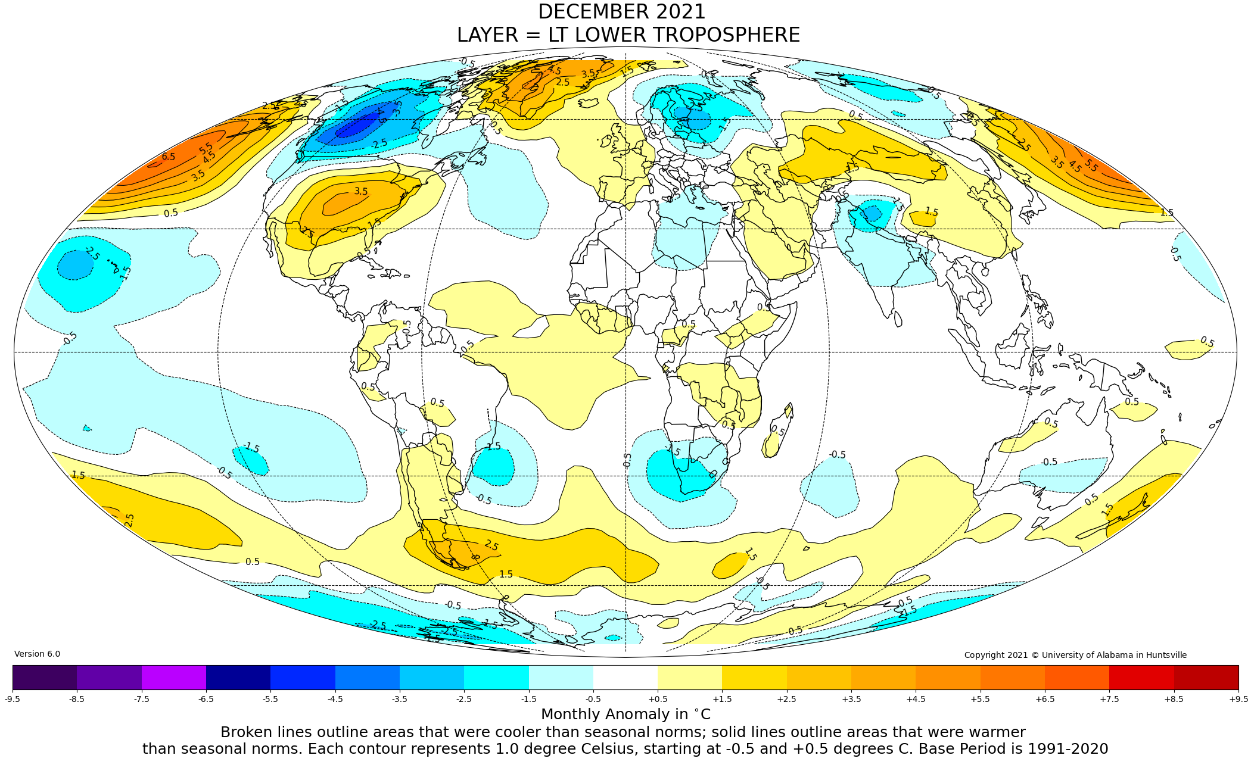
Figure. Lower tropospheric temperature anomalies for December 2021

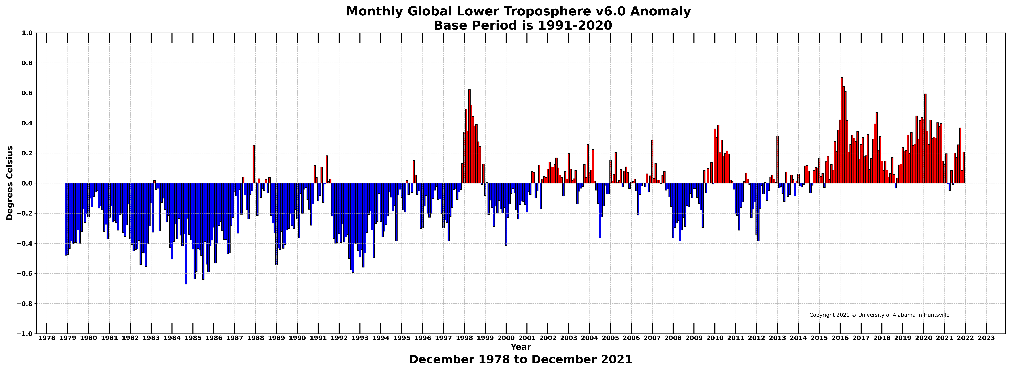
Figure. Bar chart of global monthly lower tropospheric temperature anomalies.

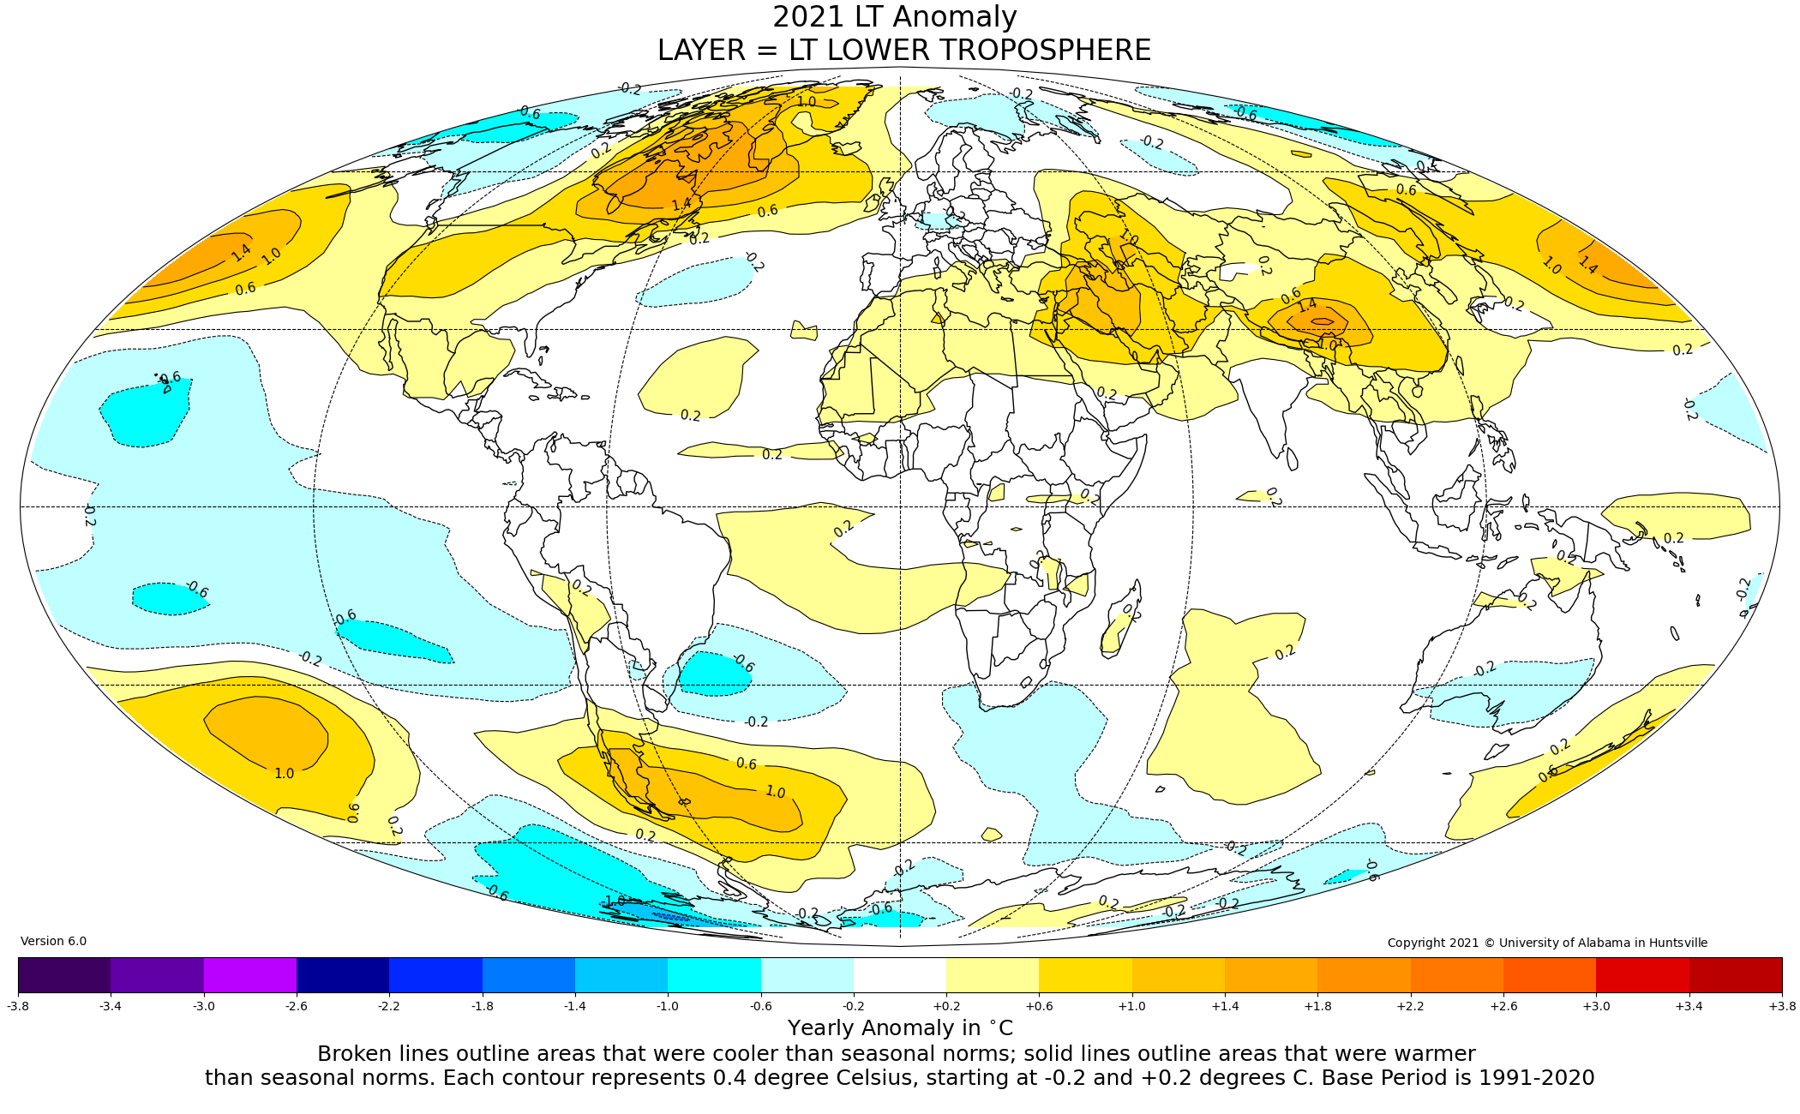

Figure. Map of 2021 annual anomalies relative to 1991-2020.

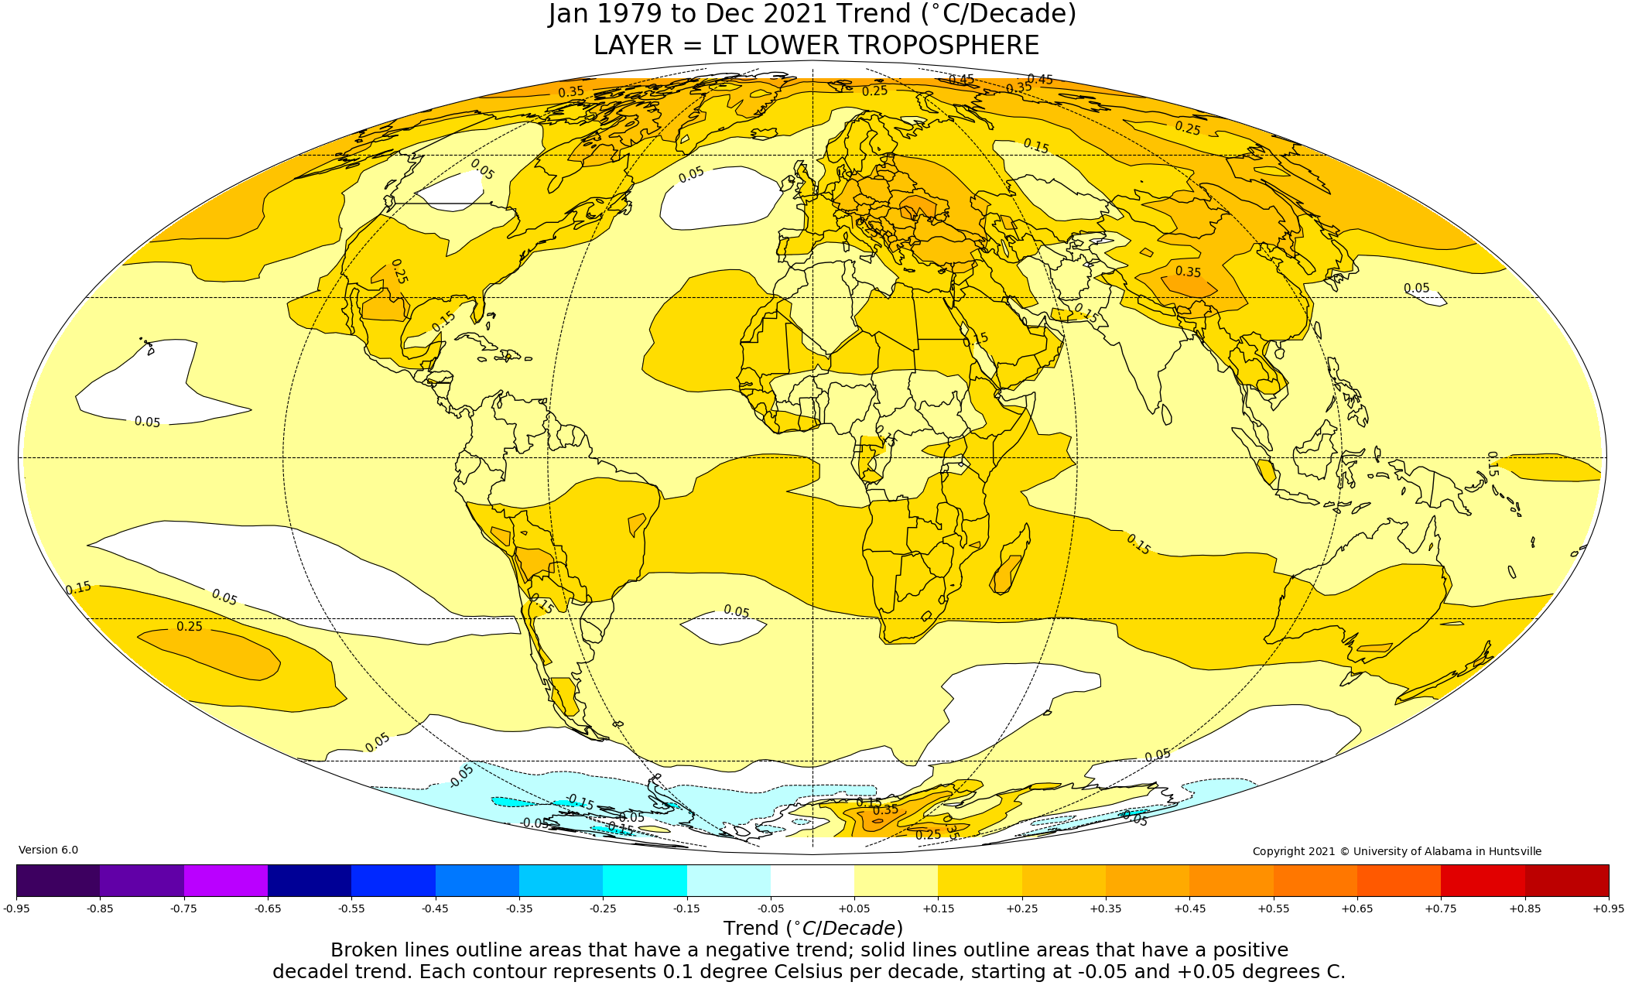
Figure. Map of grid-point temperature trends since Dec 1978.

