May 3, 2021

Vol. 32, No. 1

For Additional Information:
Dr. John Christy, (256) 961-7763
christy@nsstc.uah.edu
Dr. Roy Spencer, (256) 961-7960
spencer@nsstc.uah.edu

Global Temperature Report: April 2021
(New Reference Base, 1991-2020)

Global climate trend since Dec. 1 1978: +0.14 C per decade

April Temperatures (preliminary)

Global composite temp.: -0.05 C (-0.09 °F) below seasonal average

Northern Hemisphere: +0.05 C (+0.09 °F) above seasonal average

Southern Hemisphere: -0.15 C (-0.27 °F) below seasonal average

Tropics: -0.28 C (-0.50 °F) below seasonal average

March Temperatures (final)

Global composite temp.: -0.01 C (-0.02 °F) below seasonal average

Northern Hemisphere: +0.12 C (+0.22 °F) above seasonal average

Southern Hemisphere: -0.14 C (-0.25 °F) below seasonal average

Tropics: -0.29 C (-0.52 °F) below seasonal average

Notes on data released May 3, 2021 (v6.0, with new reference base)

This is the period in the La Niña-induced cooling cycle where the global temperature typically reaches its coolest value. NOAA again reports that the water temperatures in the tropical Pacific are still below average - about the same as March - but much warmer than last November and December.
(https://www.cpc.ncep.noaa.gov/products/analysis_monitoring/lanina/enso_evolution-status-fcsts-web.pdf)

The global departure from average of -0.05 °C (-0.09 °F) represents a slight cooling from March led by declines in the atmosphere’s temperature over the Northern Hemispheric land areas. A key indicator of the next few months’ temperature is the tropical anomaly which in April was essentially the same as March. This is an indication that this cool episode is likely bottoming-out around 0.4 °C cooler than last August to November. Will the La Niña return next fall? Will there be neutral conditions? We are in the time of year called a forecast barrier beyond which it is difficult to predict what the next winter will see in terms of La Niña/El Niño/Neutral conditions. The indicators will start showing their hand in the latter part of the northern summer.

The warmest grid cell, in terms of departure from average, was +3.7 °C (+6.7 °F) over the Bering Sea just north of the Rat Islands (part of the Aleutian chain). Anomalous warmth centered there spread to the western conterminous US and eastward to the Russian coast. Other areas of anomalous warmth were in NE Canada, western Russia southward to the Caspian Sea, the South Pacific and Argentina eastward into the South Atlantic.

The coldest departure from average was over the Baltic Sea just north of Poland at -3.2 °C (-5.8 °F). This cool region stretched from the Arctic southward to the Mediterranean Sea. Additional cool areas were found in north-central Canada, the African Sahel, India to western China, and several regions over the oceans, especially the southern oceans, primarily related to La Niña.

The conterminous US cooled from March’s warmth to -0.02 °C (-0.04 °F), almost exactly at the 30-year average. As is often the case the average is a small residual of two contrasting areas – the West was warm and the East was cool. Adding in Alaska’s above average temperature puts the 49-state average at +0.10 °C (+0.18 °F) - still very close to the average. [We don’t include Hawaii in the US results because its land area is less than that of a satellite grid square, so it would have virtually no impact on the overall national results.]

New Reference Base Jan 2021. As noted in the Jan 2021 GTR, the situation comes around every 10 years when the reference period or “30-year normal” that we use to calculate the departures is redefined. With that, we have averaged the absolute temperatures over the period 1991-2020, in accordance with the World Meteorological Organization’s guidelines, and use this as the new base period. This allows the anomalies to relate more closely to the experience of the average person, i.e. the climate of the last 30 years. Due to the rising trend of global and regional temperatures, the new normals are a little warmer than before, i.e. the global average temperature for Januaries for 1991-2020 is 0.14 °C warmer than the average for Januaries during 1981-2010. So, the new departures from this now warmer average will appear to be cooler, but this is an artifact of simply applying a new base period. It is important to remember that changes over time periods, such as a trend value or the relative difference of one year to the next, will not change. Think about it this way, all we’ve done is to take the entire time series and shifted it down a little.

To-Do List: There has been a delay in our ability to utilize and merge the new generation of microwave sensors (ATMS) on the NPP and JPSS satellites. As of now, the calibration equations applied by the agency have changed at least twice, so that the data stream contains inhomogeneities which obviously impact the type of measurements we seek. We are hoping this is resolved soon with a dataset that is built with a single, consistent set of calibration equations. In addition, the current non-drifting satellite operated by the Europeans, MetOP-B, has not yet been adjusted or “neutralized” for its seasonal peculiarities related to its unique equatorial crossing time (0930). While these MetOP-B peculiarities do not affect the long-term global trend, they do introduce error within a particular year in specific locations over land.

As part of an ongoing joint project between UAH, NOAA and NASA, Christy and Dr. Roy Spencer, an ESSC principal scientist, use data gathered by advanced microwave sounding units on NOAA, NASA and European satellites to produce temperature readings for almost all regions of the Earth. This includes remote desert, ocean and rain forest areas where reliable climate data are not otherwise available. Drs. Danny Braswell and Rob Junod assist in the preparation of these reports.

The satellite-based instruments measure the temperature of the atmosphere from the surface up to an altitude of about eight kilometers above sea level. Once the monthly temperature data are collected and processed, they are placed in a "public" computer file for immediate access by atmospheric scientists in the U.S. and abroad.

The complete version 6 lower troposphere dataset is available here:

http://www.nsstc.uah.edu/data/msu/v6.0/tlt/uahncdc_lt_6.0.txt

Archived color maps of local temperature anomalies are available on-line at:

http://nsstc.uah.edu/climate/

Neither Christy nor Spencer receives any research support or funding from oil, coal or industrial companies or organizations, or from any private or special interest groups. All of their climate research funding comes from federal and state grants or contracts.

--30—

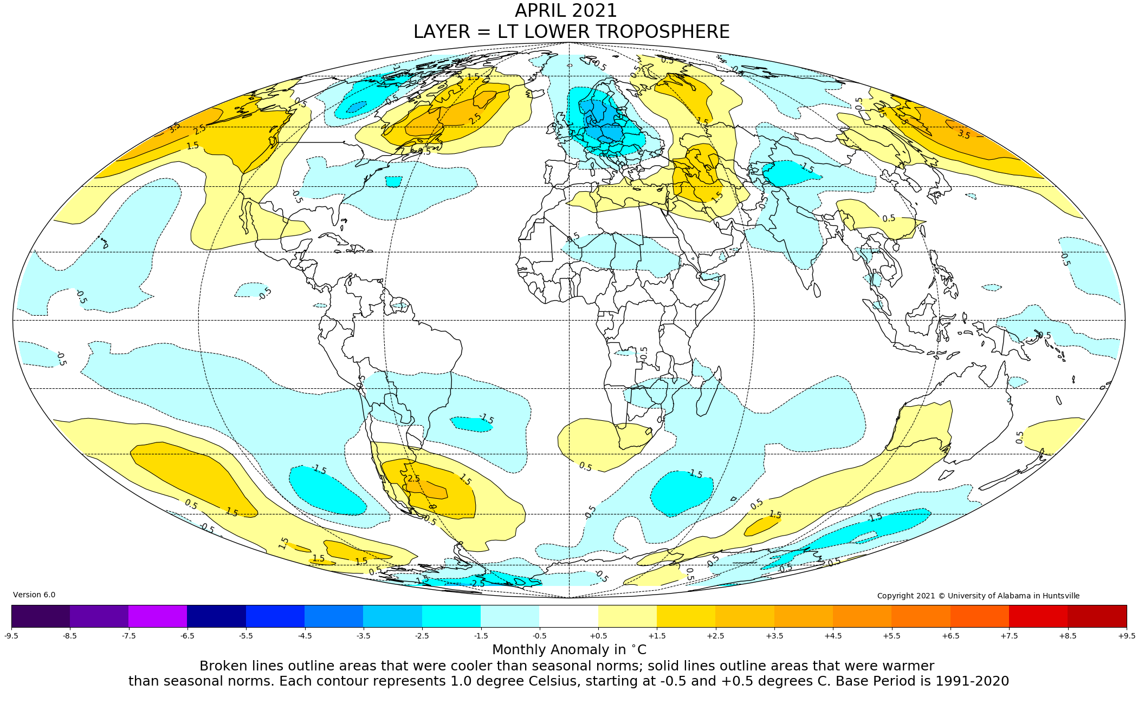

Figure. Lower tropospheric temperature anomalies for April 2021

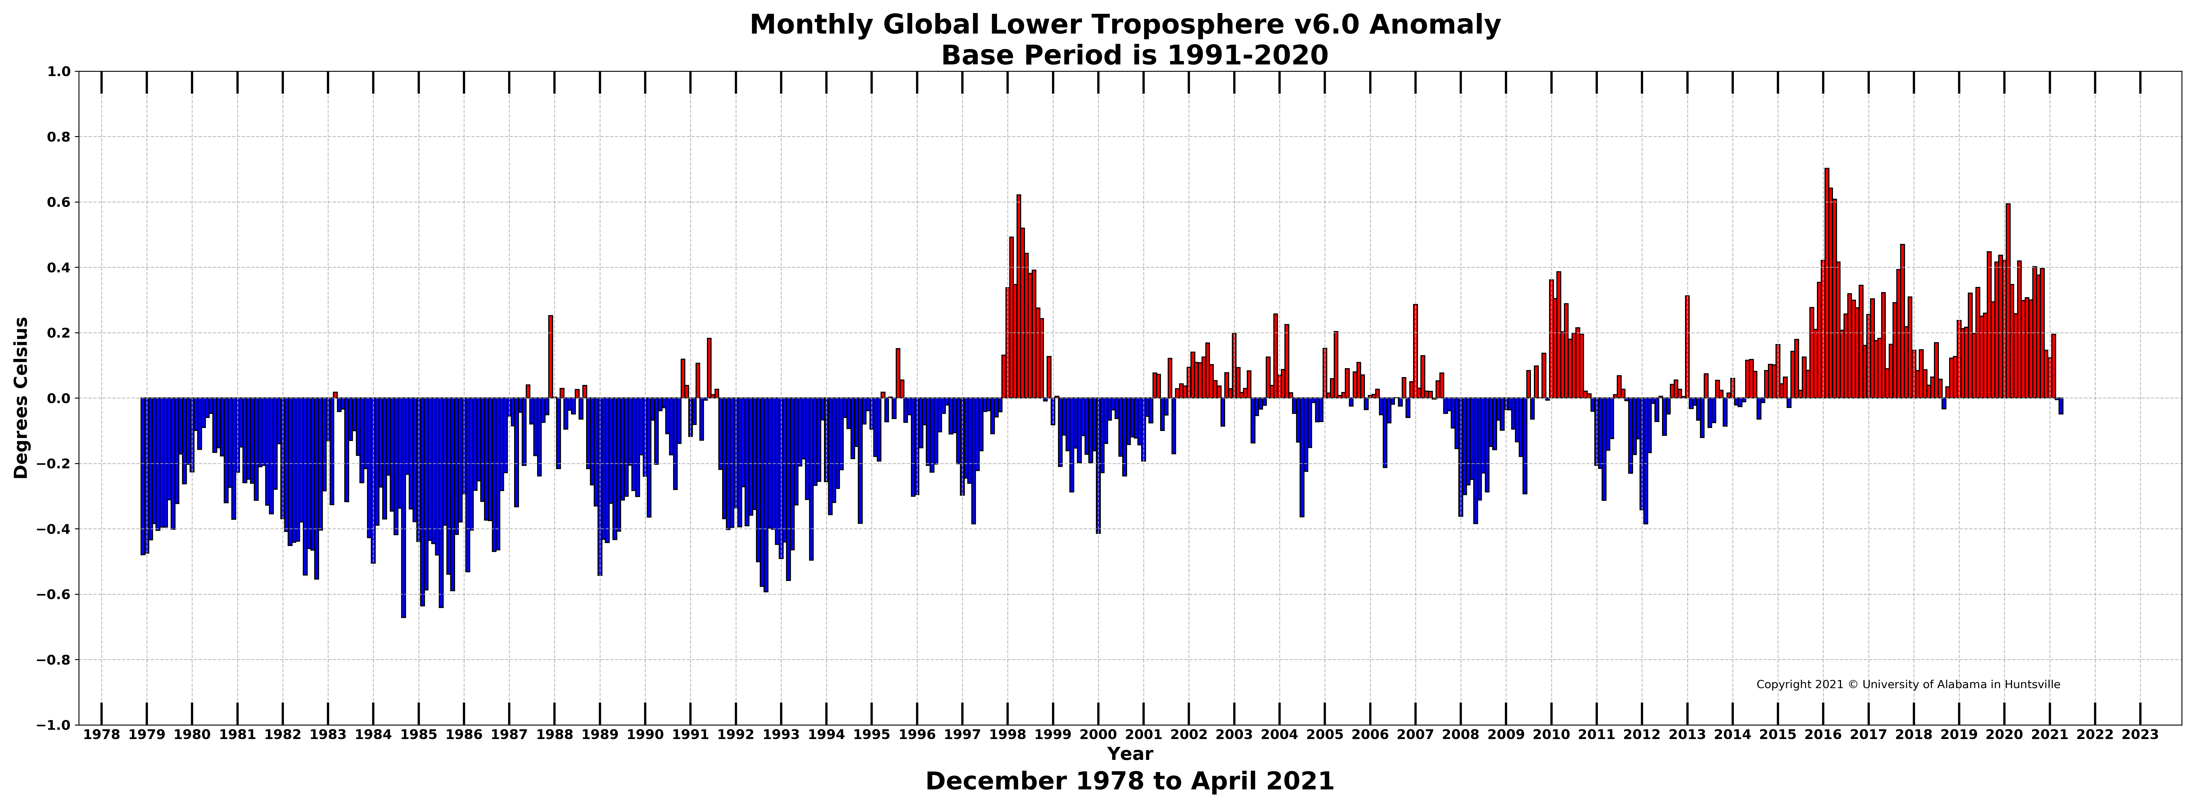

Figure. Bar chart of global monthly lower tropospheric temperature anomalies.

