

Activity Log for Differential Absorption
Lidar (DIAL) System in RAPCD Lab

UAH/NASA/MSFC
Huntsville, AL

Team Members:

John Burris
Maurice Jarzembski
Steve Johnson
Shi Kuang
Mike Newchurch
John Outerbridge
Table of Contents

Field Stop Selection……………………………………………………………………….. 3
High Channel Linearity Verification and PMT Gate Selection...………………………6
Comparison of 1 Vs. 2 Solar Filters for Nighttime Measurements……………………. 15
Low Channel Linearity Verification…………………………………………………….. 19
Investigation of Bin Size Effect on Counts……………………………………………….25
Discriminator Threshold Selection………………………………………………………. 27
PMT Dark Counts…………………………………………………………………………30

Field Stop Selection
2/13/04

Purpose: Select a field stop such that saturation on the High Channel PMT is eliminated and the background noise is reduced without compromising high altitude signal retrieval.

Procedure: The signal from the discriminator is fed into the input of a digital counter that is gated to count signals from an altitude of approximately 3Km and higher.

Each turning mirror is aligned such that counts are maximized.

Data is collected with this alignment and with different field stops, starting at 3mr down to .5mrad.

Laser Power (With UV Filter): 291 ~ 10mW
285 ~ 5mW
Weather Conditions: Clear
Plotted Data
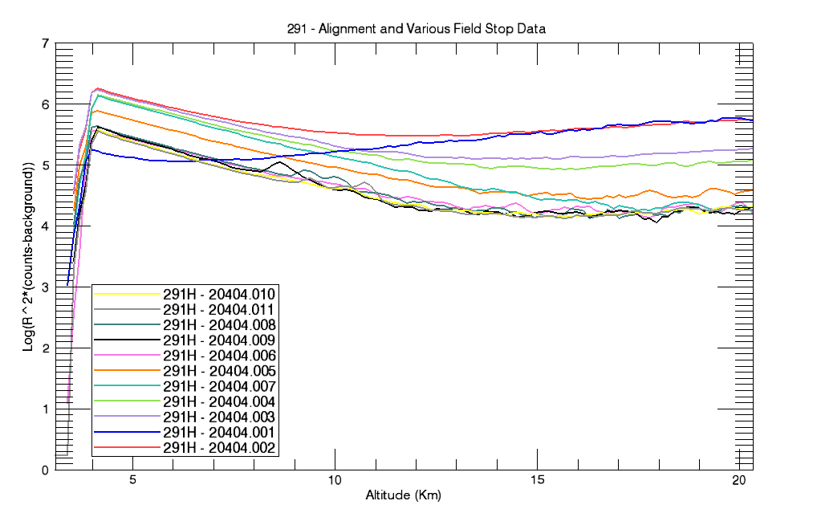

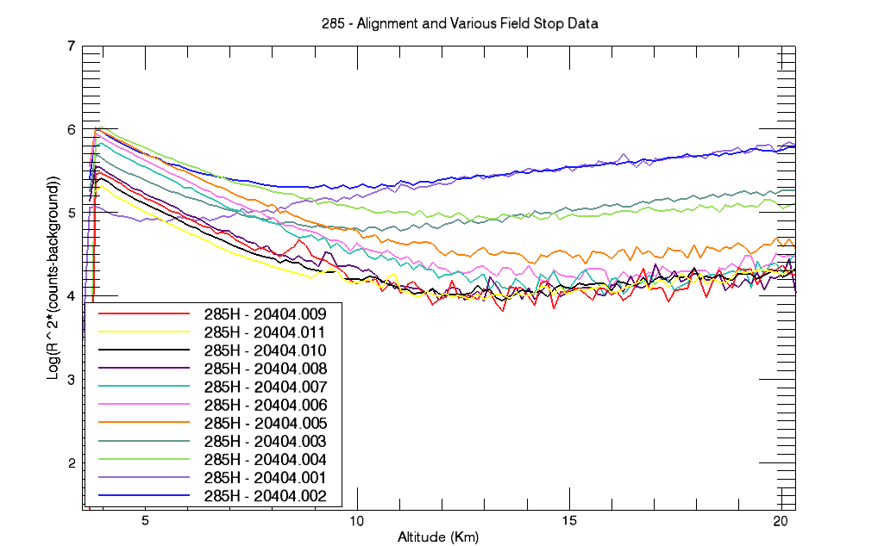Note: All plots have been scaled to 6000 integrations

File Parameter Table

File Name | Field Stop | Aligned | Integrations | UV Filters
20404.001 | None | No | 1200 | In
20404.002 | None | No | 6000 | Out
20404.003 | 3 mr | No | 6000 | Out
20404.004 | 3 mr | Yes | 6000 | Out
20404.005 | 1.5 mr | No | 6000 | Out
20404.006 | 1 mr | No | 6000 | Out
20404.007 | 1 mr | Yes | 6000 | Out
20404.008 | 0.5 mr | No | 6000 | Out
20404.009 | 0.5 mr | Yes | 6000 | Out
20404.010 | 0.5 mr | No | 36000 | Out
20404.011 | 0.5 mr | No | 36000 | Out

Discussion of Data: To reduce background noise and keep the signal counts high, it is evident from the plots that significant signal loss doesn’t occur until the .5mrad field stop is used. Using the 1mrad filed stop still achieved counts that peak close to the values of field stops with greater FOV, however, the 1.5mrad field stop allows for retrieval of counts from a higher altitude. The 1.5mrad or 1mrad field stop may used with a trade off of background counts for altitude.

Linearity Verification and PMT Gate Selection
2/18/04

Purpose: Verify High Channel PMT is operating in linear region and select a gate delay that prevents saturation, and hence, signal induced noise.

Procedure: Multiple profiles taken with the following parameters:

Gate delay (µs): 0, 5, 10, 15
Neutral Density (ND) Filter Value: .5, .25, .125, .0625, .01

Profiles are taken at each set gate delay, and with each filter. The table below specifies which files are taken and the settings that it corresponds to.

File Name | Integrations | Field Stop | Aligned | # Solar Filters | ND Filter Value | Gate Delay  (µs)
21804.001 | 1200 | 1 | Yes | 2 | NA | 0
21804.002 | 1200 | 1 | No | 2 | NA | 5
21804.003 | 1200 | 1 | No | 2 | NA | 10
21804.004 | 1200 | 1 | Yes (285) | 2 | NA | 15
21804.005 | 6000 | 1 | No | 2 | NA | 10
21804.006 | 24000 | 1 | No | 2 | NA | 10
21804.007 | 1200 | 1 | Yes (285) | 2 | NA | 10
21804.008 | 36000 | 1 | No | 2 | NA | 10
21804.009 | 1200 | 1.5 | No | 2 | NA | 10
21804.010 | 36000 | 1.5 | No | 2 | NA | 10
21804.011 | 6000 | 1 | No | 2 | NA | 15
21804.012 | 6000 | 1 | No | 2 | NA | 10
21804.013 | 6000 | 1 | No | 2 | NA | 5
21804.014 | 6000 | 1 | No | 2 | NA | 0
21804.015 | 6000 | 1 | No | 2 | 0.5 | 0
21804.016 | 6000 | 1 | No | 2 | 0.5 | 5
21804.017 | 6000 | 1 | No | 2 | 0.5 | 10
21804.018 | 6000 | 1 | No | 2 | 0.5 | 15
21804.019 | 6000 | 1 | No | 2 | 0.25 | 15
21804.020 | 6000 | 1 | No | 2 | 0.25 | 10
21804.021 | 6000 | 1 | No | 2 | 0.25 | 5
21804.022 | 6000 | 1 | No | 2 | 0.25 | 0
21804.023 | 6000 | 1 | No | 2 | 0.125 | 0
21804.024 | 6000 | 1 | No | 2 | 0.125 | 5
21804.025 | 6000 | 1 | No | 2 | 0.125 | 10
File Name | Integrations | Field Stop | Aligned | # Solar Filters | ND Filter Value | Gate Delay  (µs)
21804.026 | 6000 | 1 | No | 2 | 0.125 | 15
21804.027 | 6000 | 1 | No | 2 | 0.0625 | 15
21804.029 | 6000 | 1 | No | 2 | 0.0625 | 5
21804.030 | 6000 | 1 | No | 2 | 0.0625 | 0
21804.031 | 6000 | 1 | No | 2 | 0.01 | 0
21804.032 | 6000 | 1 | No | 2 | 0.01 | 5
21804.033 | 6000 | 1 | No | 2 | 0.01 | 10
21804.034 | 6000 | 1 | No | 2 | 0.01 | 15

Laser Power (With UV Filter): 291 ~ 10mW
285 ~ 5mW

Weather Conditions: Clear

Data & Plots
0 Delay Data Files:
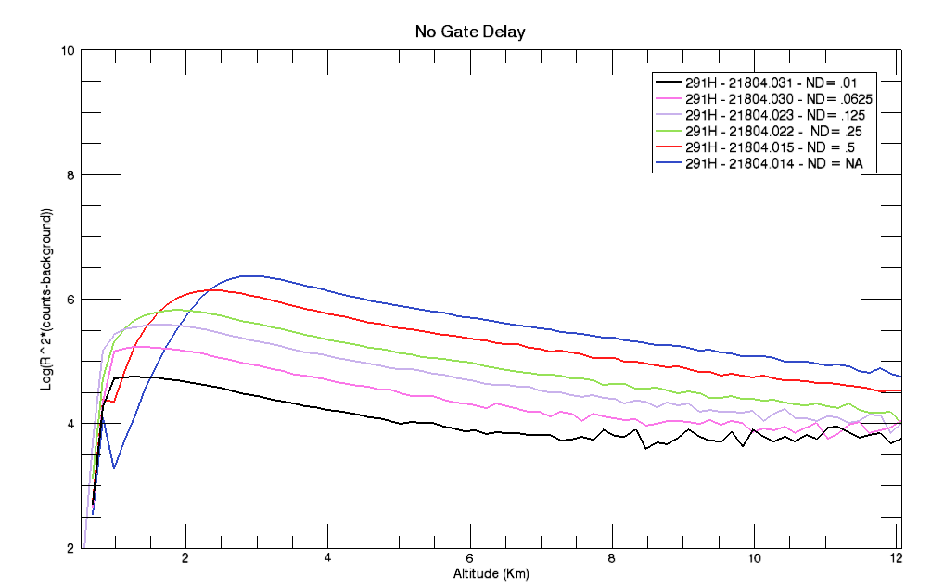
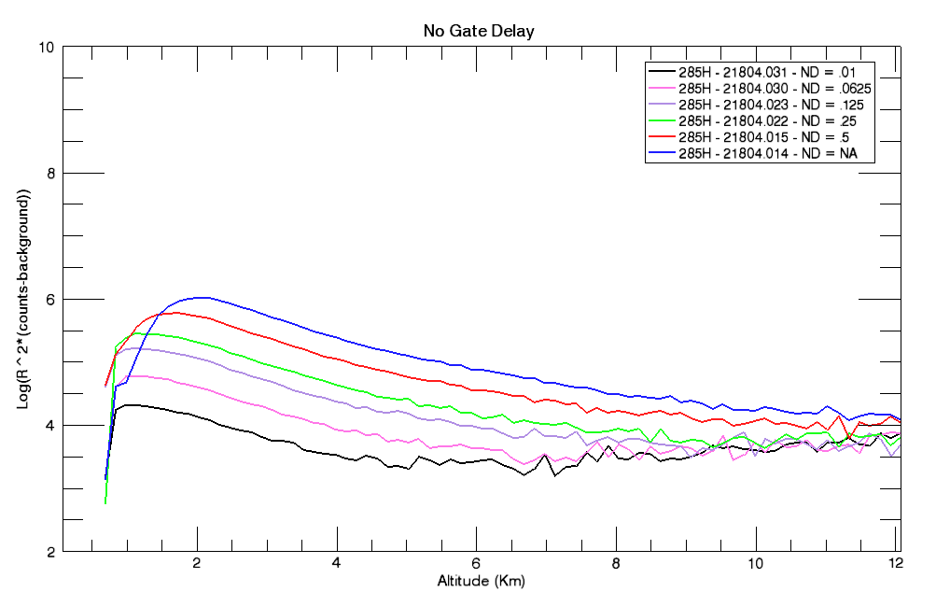

5 Micro-second Delay Files:

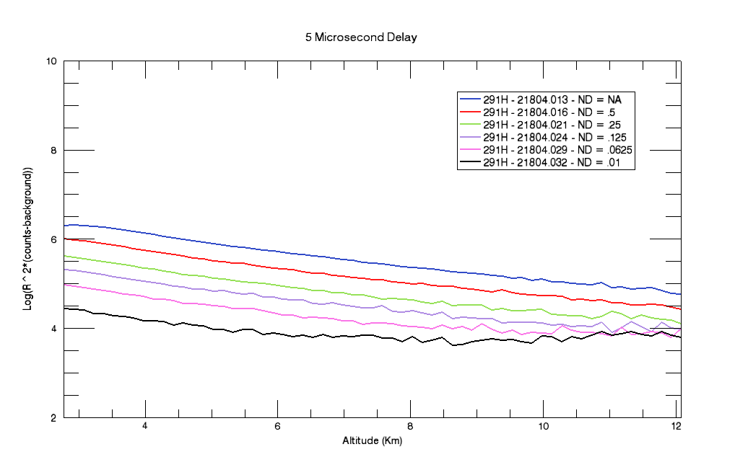

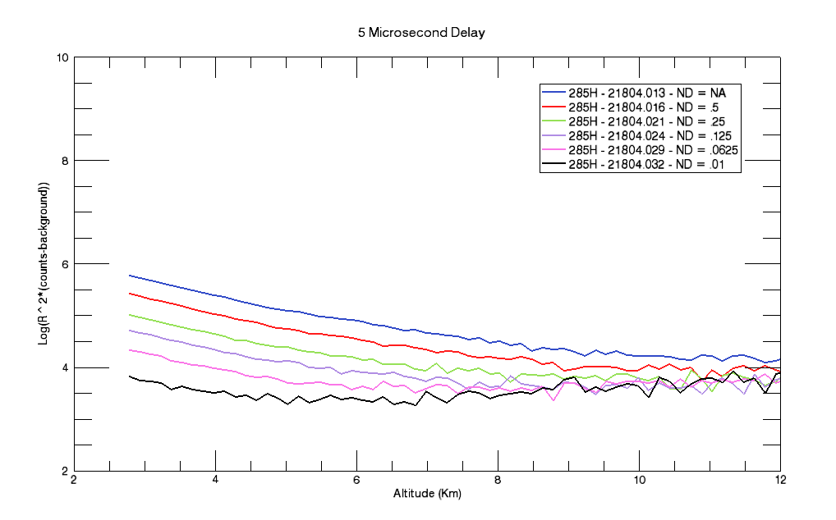

10 Micro-second Delay Files:
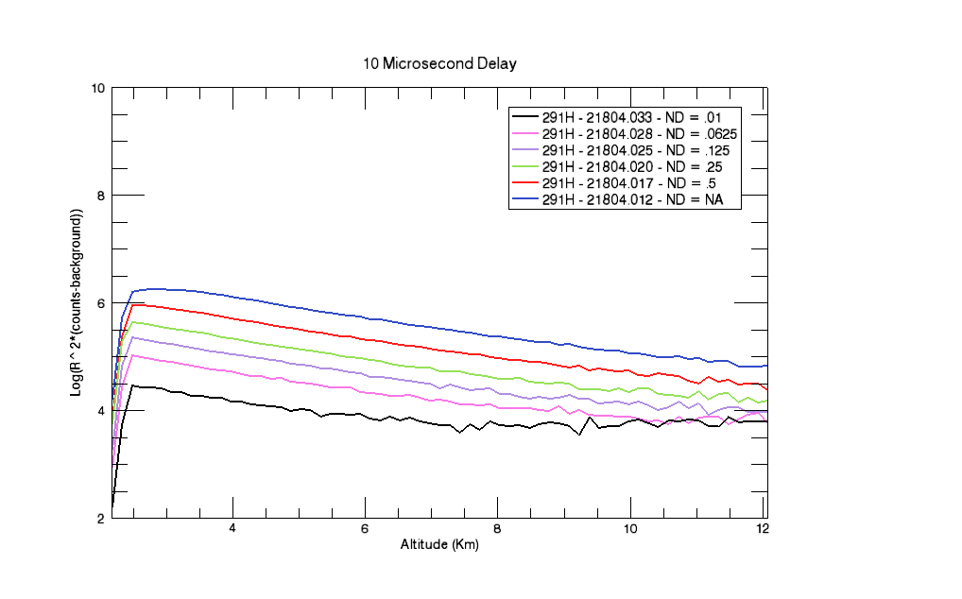

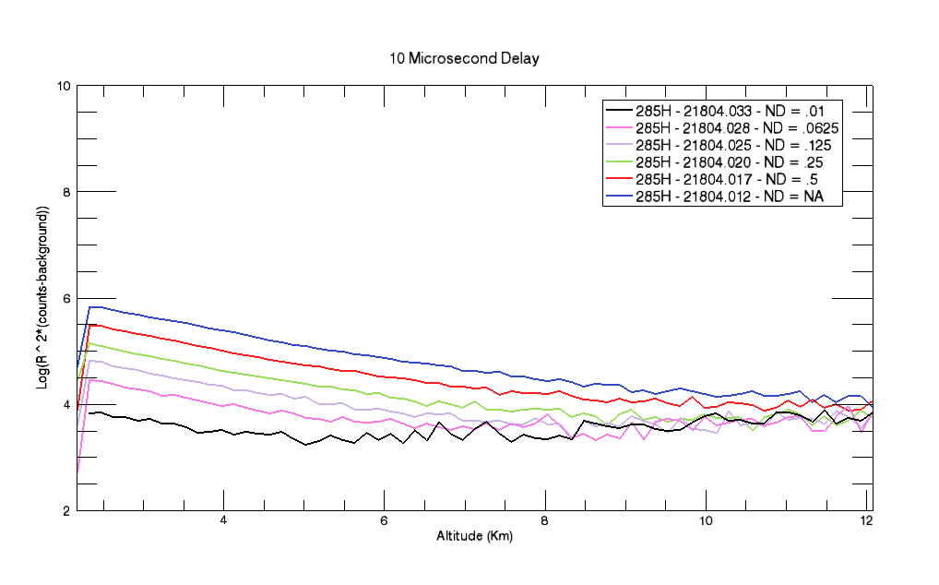

15 Micro-second Delay Files:

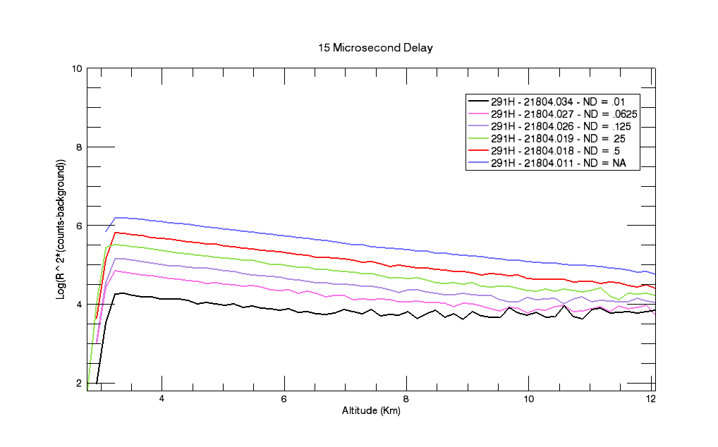

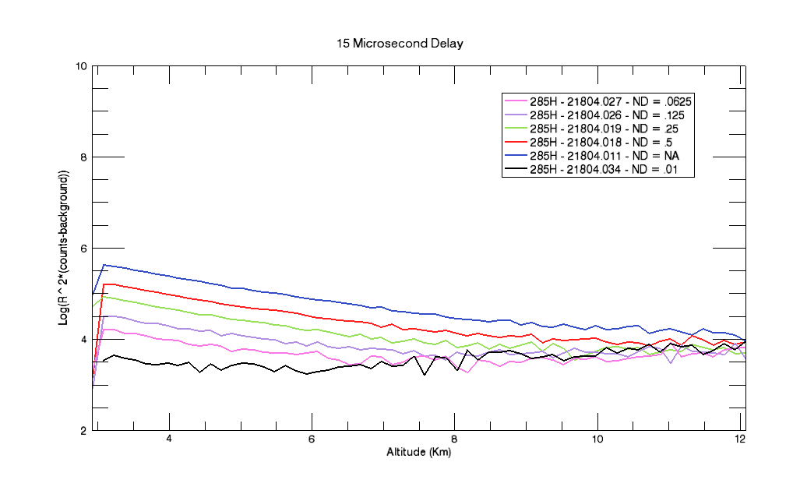

Discussion of Data:

The data indicates that the PMT is operating within the linear response region and ND filters are not necessary to attenuate the signal. As the attenuation is increased due to the ND filters, the plots show that the values in the higher altitudes tend to stop decreasing and begin to increase. This is due to how the data is being plotted. The Y axis, as indicated in the plots, is Log(R² * (counts – background)). As the counts decrease to zero, the argument of the Logarithm then increases as R².

Comparison of 1 Vs. 2 Solar Filters for Nighttime Measurements
2/19/04

Purpose: To determine if higher altitude signal retrieval is possible without inducing saturation at low altitudes by using 1 solar filter instead of 2 for profiles taken during nighttime hours when solar UV radiation is not of concern.

Procedure: Align both 291 and 285 channels with counter gated at 4km. Take a 30 minute profile with 2 solar filters and repeat 30 minute profile with 1 solar filter. Ozone Profile is also taken using the Balloon around the same pm time frame.

Laser Power (With UV Filter): 291 ~ 10mW
285 ~ 7.5mW

Weather Conditions: High, thin clouds

Plotted Data
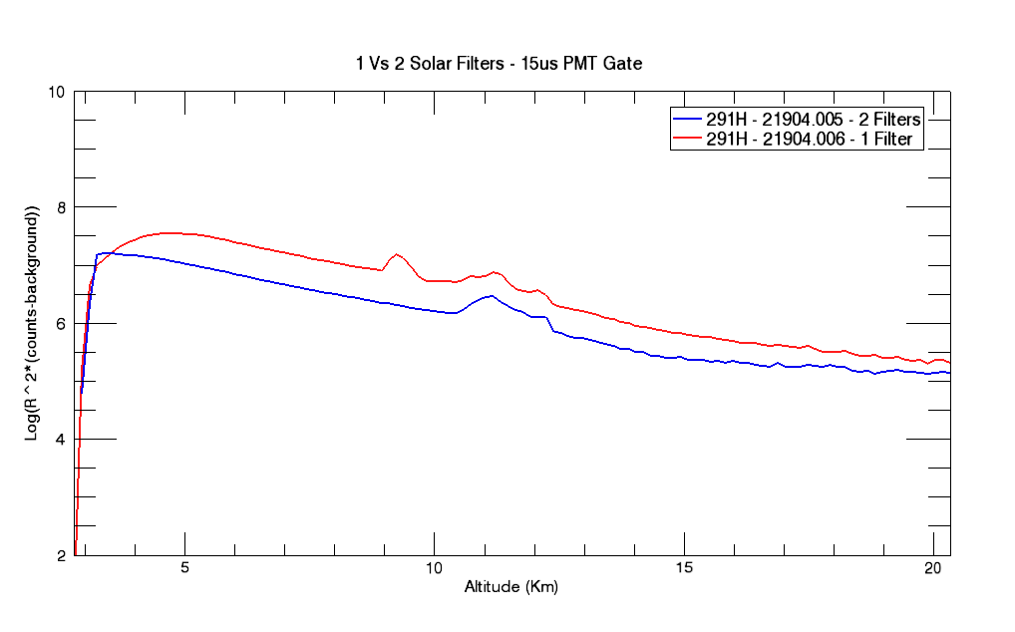

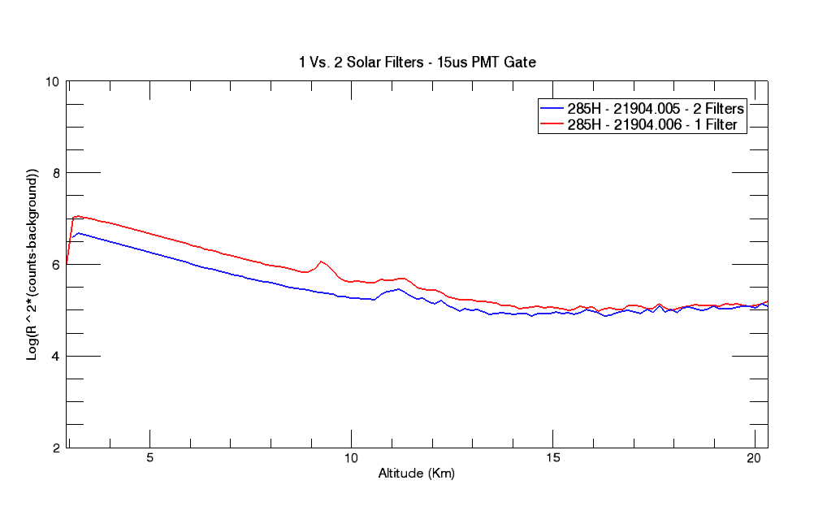

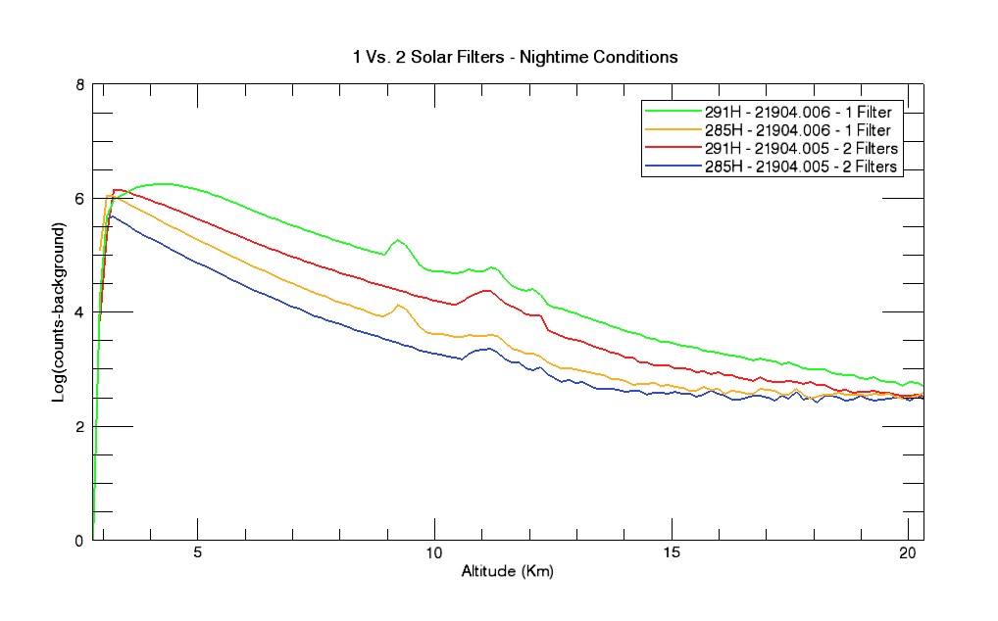

Associated Data Files:

Discussion of Data: There is a clear increase of signal at the higher altitudes using only 1 solar filter instead of 2 as expected. Future data will determine if saturation occurs as laser output power is increased. To maintain the higher altitude data, a longer PMT delay may have to be introduced if saturation at the lower altitudes is present. However, the low signal will still be recovered using the low channel data.

Low Channel Linearity Verification

Date: 3/3/04

Purpose: To verify the low channel PMT is operating in the linear region.

Verification: Data was collected with low channel PMT active and NDF’s with values of .5, .25, .125, .0625, and .01 were used to verify that the return signal is linearly proportional to NDF value.

Conditions: Partly Sunny. Low channel constantly gated

File Integrations ND Filter Previously
(Comment) Aligned

3304.001 6000 None No
(XMTR Filters In)
3304.002 6000 None No

3304.003 6000 None Yes (4Km)
3304.004 6000 0.5 No
3304.005 6000 0.25 No
3304.006 6000 0.25(0.5) No
3304.007 6000 0.25(0.5)(0.5) No 291
(power fluctuating,
bubbles in mo,
added 100 ml Me.)

3304.008 6000 0.01 No
3304.009 18000 0.25(0.5) No
3304.010 18000 0.25(0.5) No
(Clear)
3304.011 18000 0.25(0.5)(0.5) No

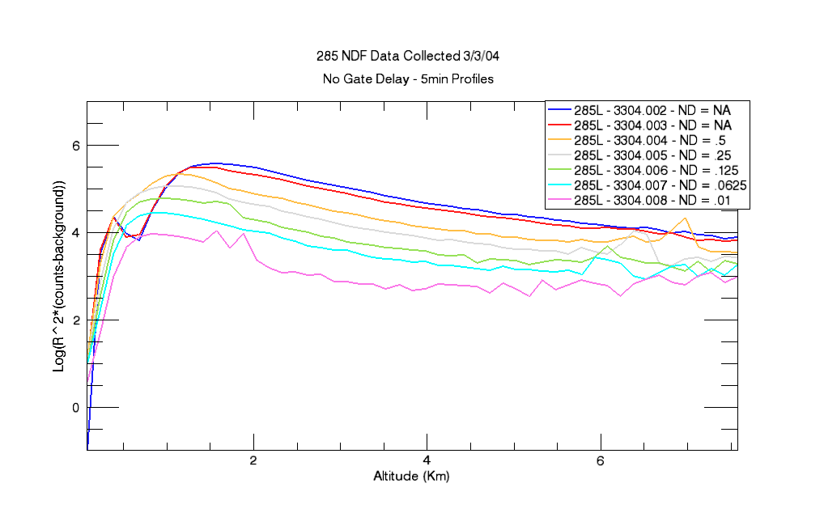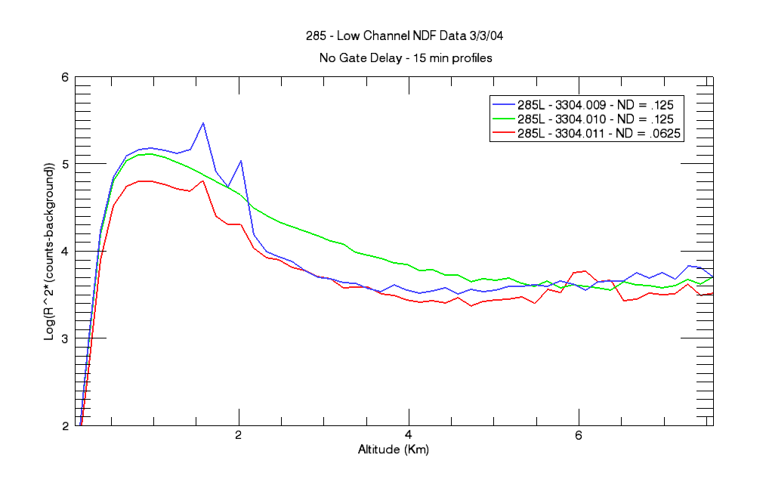

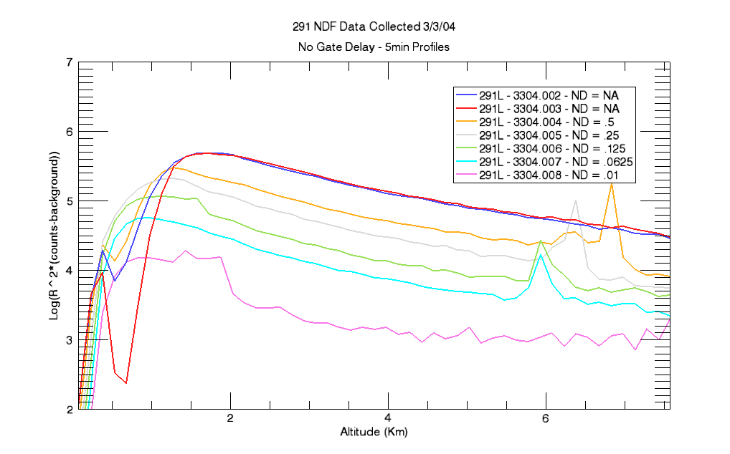
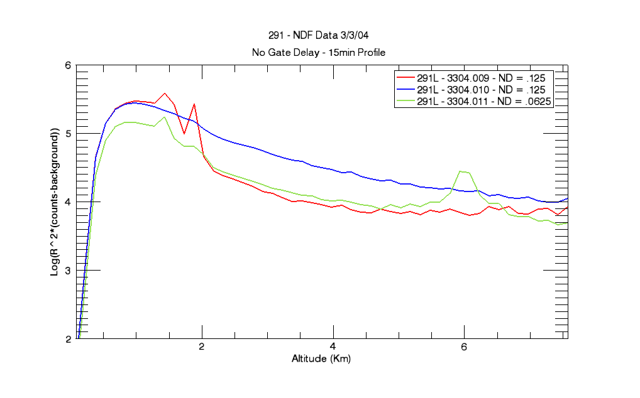

Discussion of Data:
Saturation appears evident in all [R² x (counts – background)] plots (smooth instead of sharp peak) indicating that even with ND filters, a PMT gate delay may have to be introduced to avoid signal induced noise from the outgoing pulse. The ratio plots have two areas where peaks are found – centered around ~1 and 6.5-7.5 Km. The peak at the low altitude is due to the dips in the signal from the two data sets collected with no NDF’s. The cause of the dips is suspected to be the recovery of the PMT response to the initial outgoing pulse evident in the NDF plots for the two data sets mentioned. The linear region (approximately constant valued) from 2 – 5.5Km should have a value that is very close to the value of the NDF filter. However, these filter values do not correspond to the wavelengths that are being transmitted. Measuring the transmission values for each filter proved difficult due to large power fluctuations, which turned out to be a leaky cell for the top laser, and the bottom laser is suffering from a dying flashlamp. Crude measurement data did show that for the 291 and 285, the transmission was less than the manufacturers specs, with the 285 being even less than the 291 as evident in the above plots. Once the flashlamps have been changed and dye cell fixed, accurate transmission values will be given.

Investigation of Bin Size Effect on Counts

3/22/04

Purpose: Verify that the counts scale linearly as the bin size (range gate) varies in width, i.e. if the bin size is doubled in magnitude, then the counts per bin should also approximately double.

Verification: Using room light as a source, data was collected with room light, RCVR UV filters removed, top shutter removed, and high and low channel shutters adjusted to give desired counts per microsecond prior to collecting data. Count rates set at 0.1 counts per microsecond and 10 counts per microsecond. PMT's gated as when last collected atmospheric data. Range gate clocks set at 250 ns, 500 ns, 1 μs, 2 μs, and 4 μs.

Data Table

File Range Gate Clock 1 μs Count Rate Integration

32204.005 1 us 0.1 6000
32204.006 2 us 0.1 6000
32204.007 4 us 0.1 6000
32204.008 500 ns 0.1 6000
32204.009 250 ns 0.1 6000
32204.010 1 us 10 6000
32204.011 2 us 10 6000
32204.012 4 us 10 6000
32204.013 500 ns 10 6000
32204.014 250 ns 10 6000

Results: File Ch1. Ch2. Ch4. Ch5. Target Value
(Reference file - .005)
32204.006 2.01 2.00 2.03 2.03 2.0
32204.007 3.95 3.9 4.02 4.0 4.0
32204.008 .493 .493 .511 .513 .5
32204.009 .25 .245 .26 .26 .25

(Reference file - .010)
32204.011 2.0 1.99 2.02 1.92 2
32204.012 3.96 3.93 4.01 3.94 4
32204.013 .5 .497 .503 .501 .5
32204.014 .248 .246 .25 .249 .25

Discussion of Data

Results indicate that all numbers for all bin sizes are close enough to the target value for the bin size to be of no significant concern. Bin size will be determined by the resolution desired.

Discriminator Threshold Selection

Purpose: It was found that the profiles taken with a discriminator threshold value of -75mV for all channels appeared to result in counts, taken with room light, whose statistical nature did not reflect a Poisson distribution for the PMT used for the high channel (channels 4 and 5). Namely, the standard deviation was not equal to (or approximately equal to) the square root of the mean. Double pulsing from ringing on the PMT signal was determined to be the likely culprit.

Verification: The signals from both PMT’s were examined for ringing using an oscilloscope. The output signal from the amplifier and discriminator were also looked at to determine if double pulsing was occurring. A range of discriminator thresholds was then determined to be used as a test case using room light and evaluating the results. Using room light, the shutters on both PMT’s were adjusted such that the count rate was approximately 1 pulse per microsecond (verified using external counter gated at 1 microsecond). The discriminator threshold was adjusted on channels 1 and 4 from 40mV up to 150mV in 10mV intervals. Further thresholds up to 250mV were also examined. The standard deviation was compared to the square root of the mean for each data set.

Data: Data is tabulated on next page

Note: Discriminator Thresholds vary only for Ch. 1 and Ch. 4 unless specifically stated otherwise.
 | Ch. 2 and Ch. 5 have a constant -75mV Setting.
32404 | Ch1 and Ch 4 Only | Ch. 1 |  |  |  | Ch. 2 -75mv Threshold Setting |  |  |  | Ch. 4 |  |  |  | Ch. 5 -75mv Threshold Setting
File ext. | Disc. Thres.(mV) | Mean | SD | Sqrt(Mean) | Ratio | Mean | SD | Sqrt(Mean) | Ratio | Mean | SD | Sqrt(Mean) | Ratio | Mean | SD | Sqrt(Mean) | Ratio
22 | -40 | 4925 | 77 | 70 | 1.10 | 4096 | 64 | 64 | 1.00 | 8466 | 158 | 92 | 1.72 | 4976 | 85 | 71 | 1.20
23 | -50 | 4710 | 74 | 69 | 1.08 | 4102 | 65 | 64 | 1.01 | 7092 | 136 | 84 | 1.61 | 5038 | 94 | 71 | 1.32
24 | -60 | 4556 | 75 | 67 | 1.11 | 4120 | 65 | 64 | 1.01 | 5947 | 108 | 77 | 1.40 | 5024 | 94 | 71 | 1.33
25 | -70 | 4331 | 71 | 66 | 1.08 | 4065 | 66 | 64 | 1.04 | 5125 | 99 | 72 | 1.38 | 4978 | 90 | 71 | 1.28
26 | -80 | 4190 | 65 | 65 | 1.00 | 4067 | 70 | 64 | 1.10 | 4692 | 81 | 68 | 1.18 | 4794 | 94 | 69 | 1.36
27 | -90 | 4037 | 68 | 64 | 1.07 | 4079 | 68 | 64 | 1.06 | 4330 | 74 | 66 | 1.12 | 4976 | 89 | 71 | 1.26
28 | -100 | 3844 | 64 | 62 | 1.03 | 4046 | 69 | 64 | 1.08 | 4149 | 73 | 64 | 1.13 | 4969 | 87 | 70 | 1.23
29 | -110 | 4691 | 62 | 68 | 0.91 | 4033 | 66 | 64 | 1.04 | 4054 | 72 | 64 | 1.13 | 4953 | 92 | 70 | 1.31
30 | -120 | 3562 | 68 | 60 | 1.14 | 4052 | 65 | 64 | 1.02 | 3976 | 69 | 63 | 1.09 | 4942 | 85 | 70 | 1.21
31 | -130 | 3457 | 61 | 59 | 1.04 | 4081 | 67 | 64 | 1.05 | 3924 | 68 | 63 | 1.09 | 4967 | 88 | 70 | 1.25
32 | -140 | 3316 | 58 | 58 | 1.01 | 4076 | 67 | 64 | 1.05 | 3975 | 67 | 63 | 1.06 | 4965 | 89 | 70 | 1.26
33 | -150 | 3194 | 61 | 57 | 1.08 | 4093 | 66 | 64 | 1.03 | 3811 | 65 | 62 | 1.05 | 4955 | 92 | 70 | 1.31
33004 | 9000 integrations
2 | -150 | 11352 | 110 | 107 | 1.03 | 14902 | 126 | 122 | 1.03 | 9968 | 114 | 100 | 1.14 | 12584 | 143 | 112 | 1.27
3 | -175 | 9936 | 105 | 100 | 1.05 | 14678 | 123 | 121 | 1.02 | 9505 | 102 | 97 | 1.04 | 12493 | 142 | 112 | 1.27
4 | -200 | 8830 | 95 | 94 | 1.01 | 14633 | 122 | 121 | 1.01 | 9163 | 101 | 96 | 1.05 | 12475 | 140 | 112 | 1.25
5 | -225 |  |  |  |  |  |  |  |  | 8766 | 94 | 94 | 1.00
6 | -250 |  |  |  |  |  |  |  |  | 8434 | 91 | 92 | 0.99
33104 | 9000 integrations | Ch. 1 -75mv Threshold Setting |  |  |  | Ch. 2 -75mv Threshold Setting |  |  |  | Ch. 4 (Varying Threshold) |  |  |  | Ch.5 (Varying Threshold)
1 | -100 | 15519 | 124 | 125 | 0.99 | 14979 | 133 | 122 | 1.09 | 10680 | 120 | 103 | 1.17 | 10960 | 121 | 105 | 1.16
2 | -125 | 15349 | 137 | 124 | 1.10 | 14811 | 134 | 122 | 1.10 | 10150 | 115 | 101 | 1.14 | 10479.5 | 117 | 102 | 1.15
3 | -150 | 15111 | 130 | 123 | 1.06 | 14586 | 126 | 121 | 1.05 | 9713 | 110 | 99 | 1.12 | 10015.2 | 109 | 100 | 1.09
 | Integrations | Ch. 1 -75mv Threshold Setting |  |  |  | Ch. 2 -75mv Threshold Setting |  |  |  | Ch. 4 -150mV |  |  |  | Ch. 5 -150mV
4 | 18000 | 30252 | 197 | 174 | 1.13 | 29204 | 179 | 171 | 1.05 | 19452 | 151 | 139 | 1.09 | 20080 | 161 | 142 | 1.13
5 | 36000 | 60051 | 272 | 245 | 1.11 | 57985 | 268 | 241 | 1.11 | 38778 | 225 | 197 | 1.14 | 39986 | 231 | 200 | 1.16
4104 | 18000 Integrations |  |  |  |  |  |  |  |  | Ch. 4 |  |  |  | Ch. 5
1 | -200 |  |  |  |  |  |  |  |  | 18474 | 149 | 136 | 1.09 | 18775 | 149 | 137 | 1.09
2 | -250 |  |  |  |  |  |  |  |  | 17442 | 145 | 132 | 1.10 | 17541 | 142 | 132 | 1.07
3 | -275 |  |  |  |  |  |  |  |  | 16941 | 135 | 130 | 1.04 | 17019 | 145 | 130 | 1.11
5 | -275 |  |  |  |  |  |  |  |  | 17188 | 135 | 131 | 1.03 | 17285 | 136 | 131 | 1.03
 | 36000 integrations
4 | -275 |  |  |  |  |  |  |  |  | 33747 | 206 | 184 | 1.12 | 33910 | 189 | 184 | 1.03
 |  |  |  |  |  |  |  |  |  | Avg. Ratio for -275mV |  |  | 1.062 |  |  |  | 1.057

Discussion of Data: The ratio of the standard deviation to the mean (ideal value of 1) showed a constant improvement with increasing threshold for channel 4, however, no improvement was seen on channel 1. Channel 5 showed similar improvement to increasing discriminator threshold values. Above 150mV, the ratios fluctuated and showed no trend of improvement even with longer integrations. With these results, the threshold will have a threshold (magnitude) of 150mV for the PMT corresponding to the high channels 4 and 5.

PMT Dark Counts

Purpose: Characterize the dark counts for each PMT as a function of voltage.

Verification: The output of the discriminator for the respective PMT is used as the data line for the counter which will be used to count the “dark” pulses. All solar filters are in place with room lights off and cover on top of telescope is closed. The Stanford pulse generators provide the 1 second gate used for counting pulses. The counter is set to display an average value taken over 10 gates. The voltage on the PMT is set to a low value of 1400 and increased in increments of 50V to a value of 2000V (maximum allowed voltage is 3000V).

Data: Below is a graph for the dark counts for each PMT.
Note: PMT-49 and PMT-43 have been used as the low and high PMT respectively since the receiving optics/electronics were put in place. PMT-28 and PMT-30 are the two PMT’s recently received from Goddard. Current operating voltage is 1850V.

Discussion of Data: PMT-49 has a significantly lower dark count than the rest of the PMT’s. To rule out the PMT base or housing as contributing sources, PMT-49 was used in both the base and the housing as the high PMT and performed the same as it did with its current base and housing. May consider using PMT-49 as the high PMT and PMT-28 as the low PMT.

