December 2, 2021

Vol. 32, No. 8

For Additional Information:
Dr. John Christy, (256) 961-7763
christy@nsstc.uah.edu
Dr. Roy Spencer, (256) 961-7960
spencer@nsstc.uah.edu

Global Temperature Report: November 2021
(New Reference Base, 1991-2020)

Global climate trend since Dec. 1 1978: +0.14 C per decade

November Temperatures (preliminary)

Global composite temp.: +0.08 C (+0.14°F) above seasonal average

Northern Hemisphere: +0.11 C (+0.20 °F) above seasonal average

Southern Hemisphere: +0.06 C (+0.11 °F) above seasonal average

Tropics: +0.14 C (+0.25 °F) above seasonal average

October Temperatures (final)

Global composite temp.: +0.37 C (+0.67°F) above seasonal average

Northern Hemisphere: +0.46 C (+0.83 °F) above seasonal average

Southern Hemisphere: +0.27 C (+0.49 °F) above seasonal average

Tropics: +0.33 C (+0.59 °F) above seasonal average

Notes on data released December 2, 2021 (v6.0, with new reference base)

The global temperature departure fell substantially from +0.37 °C (+0.67 °F) in October to +0.08 °C (+0.14 °F) in November, the largest month-to-month drop since February 2013. This drop is certainly related to the growing cooling impact of the tropical Pacific sea temperatures as the La Niña becomes well established. Recall last year, the major La Niña-induced drop occurred a month later. The latest on the La Niña can be found here.

https://www.cpc.ncep.noaa.gov/products/analysis_monitoring/lanina/enso_evolution-status-fcsts-web.pdf.

Following the warmest October temperatures over land (+0.61 °C), this temperature departure in November fell to +0.22 C (+0.40 °F), a 0.39 °C drop. The polar regions especially cooled, with northern high latitudes experiencing a drop of over 1 °C from October to a below-average value of -0.42 °C (-0.76 °F) with a similar drop in the southern high latitudes of -0.85 °C to -0.73 °C (-1.31 °F).

The warmest region, in terms of the monthly departure from average, was +3.8 °C (+6.8 °F) °F) near the coastal town of Ayan in far Eastern Russia. Warm departures also occurred in the western US, Canada to the North Atlantic, Black Sea, and New Zealand. The North Pacific, much of Africa eastward through China, the far South Pacific and eastern Antarctica were also above average.

The coldest grid cell appeared near King Salmon Alaska (-4.4 °C, -7.9 °F). As is often the case with monthly extremes, the coldest and warmest were relatively close in a global sense – in this case only 3,700 km (about 2,300 mi) apart or roughly the distance from Los Angeles to Atlanta. In addition to Alaska, several other colder than average areas were seen in the European/Russian Arctic, eastern US, western Mediterranean, much of the coast of Antarctica and central China eastward to Japan.

The average temperature over the conterminous US was slightly above average at +0.50 °C (+0.90 °C) which balanced a warm west and a cool east – a pattern seen often in 2021. However, as noted above, Alaska was significantly colder than normal (-3.05 °C, -5.49 °F) so when geographically-averaged with the other 48 states, the 49-state average dipped below normal at -0.05 °C (-0.09 °F). [We don’t include Hawaii in the US results because its land area is less than that of a satellite grid square, so it would have virtually no impact on the overall national results.]

New Reference Base Jan 2021. As noted in the Jan 2021 GTR, the situation comes around every 10 years when the reference period or “30-year normal” that we use to calculate the departures is redefined. With that, we have averaged the absolute temperatures over the period 1991-2020, in accordance with the World Meteorological Organization’s guidelines, and use this as the new base period. This allows the anomalies to relate more closely to the experience of the average person, i.e. the climate of the last 30 years. Due to the rising trend of global and regional temperatures, the new normals are a little warmer than before, i.e. the global average temperature for Januaries for 1991-2020 is 0.14 °C warmer than the average for Januaries during 1981-2010. So, the new departures from this now warmer average will appear to be cooler, but this is an artifact of simply applying a new base period. It is important to remember that changes over time periods, such as a trend value or the relative difference of one year to the next, will not change. Think about it this way, all we’ve done is to take the entire time series and shifted it down a little.

To-Do List: There has been a delay in our ability to utilize and merge the new generation of microwave sensors (ATMS) on the NPP and JPSS satellites. As of now, the calibration equations applied by the agency have changed at least twice, so that the data stream contains inhomogeneities which obviously impact the type of measurements we seek. We are hoping this is resolved soon with a dataset that is built with a single, consistent set of calibration equations. In addition, the current non-drifting satellite operated by the Europeans, MetOP-B, has not yet been adjusted or “neutralized” for its seasonal peculiarities related to its unique equatorial crossing time (0930). While these MetOP-B peculiarities do not affect the long-term global trend, they do introduce error within a particular year in specific locations over land.

As part of an ongoing joint project between UAH, NOAA and NASA, Christy and Dr. Roy Spencer, an ESSC principal scientist, use data gathered by advanced microwave sounding units on NOAA, NASA and European satellites to produce temperature readings for almost all regions of the Earth. This includes remote desert, ocean and rain forest areas where reliable climate data are not otherwise available. Drs. Danny Braswell and Rob Junod assist in the preparation of these reports.

The satellite-based instruments measure the temperature of the atmosphere from the surface up to an altitude of about eight kilometers above sea level. Once the monthly temperature data are collected and processed, they are placed in a "public" computer file for immediate access by atmospheric scientists in the U.S. and abroad.

The complete version 6 lower troposphere dataset is available here:

http://www.nsstc.uah.edu/data/msu/v6.0/tlt/uahncdc_lt_6.0.txt

Archived color maps of local temperature anomalies are available on-line at:

http://nsstc.uah.edu/climate/

Neither Christy nor Spencer receives any research support or funding from oil, coal or industrial companies or organizations, or from any private or special interest groups. All of their climate research funding comes from federal and state grants or contracts.

--30—

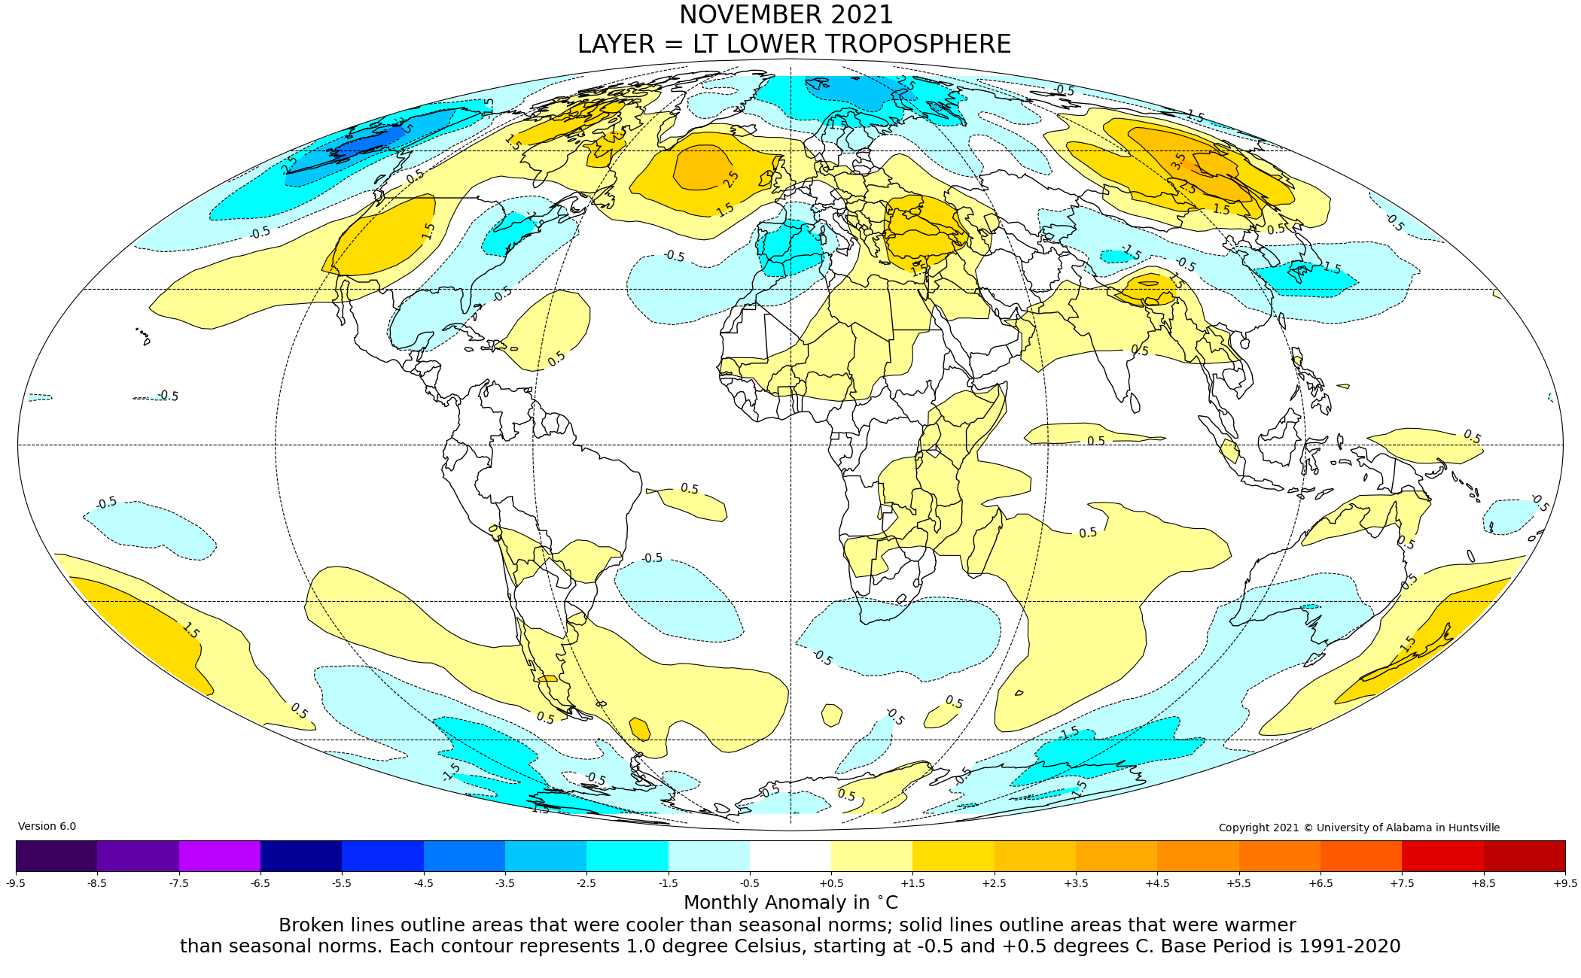
Figure. Lower tropospheric temperature anomalies for November 2021

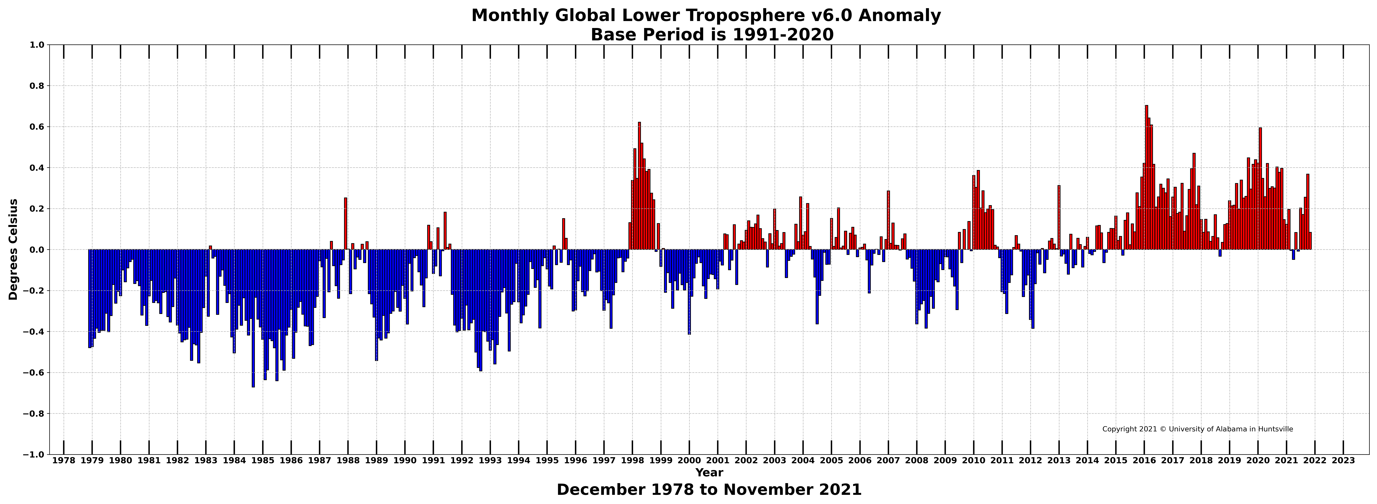

Figure. Bar chart of global monthly lower tropospheric temperature anomalies.

