September 2, 2021

Vol. 32, No. 5

For Additional Information:
Dr. John Christy, (256) 961-7763
christy@nsstc.uah.edu
Dr. Roy Spencer, (256) 961-7960
spencer@nsstc.uah.edu

Global Temperature Report: August 2021
(New Reference Base, 1991-2020)

Global climate trend since Dec. 1 1978: +0.14 C per decade

August Temperatures (preliminary)

Global composite temp.: +0.17 C (+0.31 °F) above seasonal average

Northern Hemisphere: +0.27 C (+0.49 °F) above seasonal average

Southern Hemisphere: +0.08 C (+0.14°F) above seasonal average

Tropics: +0.07 C (+0.13 °F) above seasonal average

July Temperatures (final)

Global composite temp.: +0.20 C (+0.36 °F) above seasonal average

Northern Hemisphere: +0.33 C (+0.59 °F) above seasonal average

Southern Hemisphere: +0.07 C (+0.13°F) above seasonal average

Tropics: +0.13 C (+0.23 °F) above seasonal average

Notes on data released September 2, 2021 (v6.0, with new reference base)

The global temperature departure from average was little changed from July coming in at +0.17 C (+0.31 °F). Of interest in terms of change is the tropical band which cooled from +0.13 C in July to +0.07 this past month. This is an indication that the cool-phase La Niña is likely gathering strength.

The confidence in the appearance of La Niña this coming NH winter has increased a bit to 70% as NOAA continues with its “La Niña Watch”. Back-to-back La Niñas are not unusual, so it is possible that the global temperature may dip back to average or below in several of the coming months despite the uptick in temperature in July and August. This potential fall in global temperatures for the coming months is now becoming more likely. To keep track of the latest weekly summary of the El Niño/La Niña cycle see:

https://www.cpc.ncep.noaa.gov/products/analysis_monitoring/lanina/enso_evolution-status-fcsts-web.pdf.

The warmest region, in terms of the monthly departure from average, was +3.9 C (+7.0 °F) over East Antarctica near the Concordia Research Station. The other main areas of warmer than average temperatures appeared in the NH and formed a wave pattern with warm areas from west to east occurring in the North Pacific, SE Canada, Iceland, western Russia and then eastern Russia.

The coldest grid cell was not far from the warmest being located SE of the South Sandwich Islands at -2.9 C (-5.2 °F). Cooler than average regions were found in the western North Pacific, central Europe, far South Atlantic and NE China. The tropics were very near average.

The pattern of warmer temperatures in the western conterminous US vs the eastern states continued in August. As noted last month, there is some suggestion this persistent pattern is related to the indirect effects of La Niña. Overall the 48-state average was slightly above average at +0.33 C (+0.59 °F), somewhat cooler than June’s +1.44 C and July’s +0.58 C. Adding in Alaska’s temperature doesn’t change the August value much with the 49-state average coming in at +0.28 °C (+0.50 °F). [We don’t include Hawaii in the US results because its land area is less than that of a satellite grid square, so it would have virtually no impact on the overall national results.]

New Reference Base Jan 2021. As noted in the Jan 2021 GTR, the situation comes around every 10 years when the reference period or “30-year normal” that we use to calculate the departures is redefined. With that, we have averaged the absolute temperatures over the period 1991-2020, in accordance with the World Meteorological Organization’s guidelines, and use this as the new base period. This allows the anomalies to relate more closely to the experience of the average person, i.e. the climate of the last 30 years. Due to the rising trend of global and regional temperatures, the new normals are a little warmer than before, i.e. the global average temperature for Januaries for 1991-2020 is 0.14 °C warmer than the average for Januaries during 1981-2010. So, the new departures from this now warmer average will appear to be cooler, but this is an artifact of simply applying a new base period. It is important to remember that changes over time periods, such as a trend value or the relative difference of one year to the next, will not change. Think about it this way, all we’ve done is to take the entire time series and shifted it down a little.

To-Do List: There has been a delay in our ability to utilize and merge the new generation of microwave sensors (ATMS) on the NPP and JPSS satellites. As of now, the calibration equations applied by the agency have changed at least twice, so that the data stream contains inhomogeneities which obviously impact the type of measurements we seek. We are hoping this is resolved soon with a dataset that is built with a single, consistent set of calibration equations. In addition, the current non-drifting satellite operated by the Europeans, MetOP-B, has not yet been adjusted or “neutralized” for its seasonal peculiarities related to its unique equatorial crossing time (0930). While these MetOP-B peculiarities do not affect the long-term global trend, they do introduce error within a particular year in specific locations over land.

As part of an ongoing joint project between UAH, NOAA and NASA, Christy and Dr. Roy Spencer, an ESSC principal scientist, use data gathered by advanced microwave sounding units on NOAA, NASA and European satellites to produce temperature readings for almost all regions of the Earth. This includes remote desert, ocean and rain forest areas where reliable climate data are not otherwise available. Drs. Danny Braswell and Rob Junod assist in the preparation of these reports.

The satellite-based instruments measure the temperature of the atmosphere from the surface up to an altitude of about eight kilometers above sea level. Once the monthly temperature data are collected and processed, they are placed in a "public" computer file for immediate access by atmospheric scientists in the U.S. and abroad.

The complete version 6 lower troposphere dataset is available here:

http://www.nsstc.uah.edu/data/msu/v6.0/tlt/uahncdc_lt_6.0.txt

Archived color maps of local temperature anomalies are available on-line at:

http://nsstc.uah.edu/climate/

Neither Christy nor Spencer receives any research support or funding from oil, coal or industrial companies or organizations, or from any private or special interest groups. All of their climate research funding comes from federal and state grants or contracts.

--30—

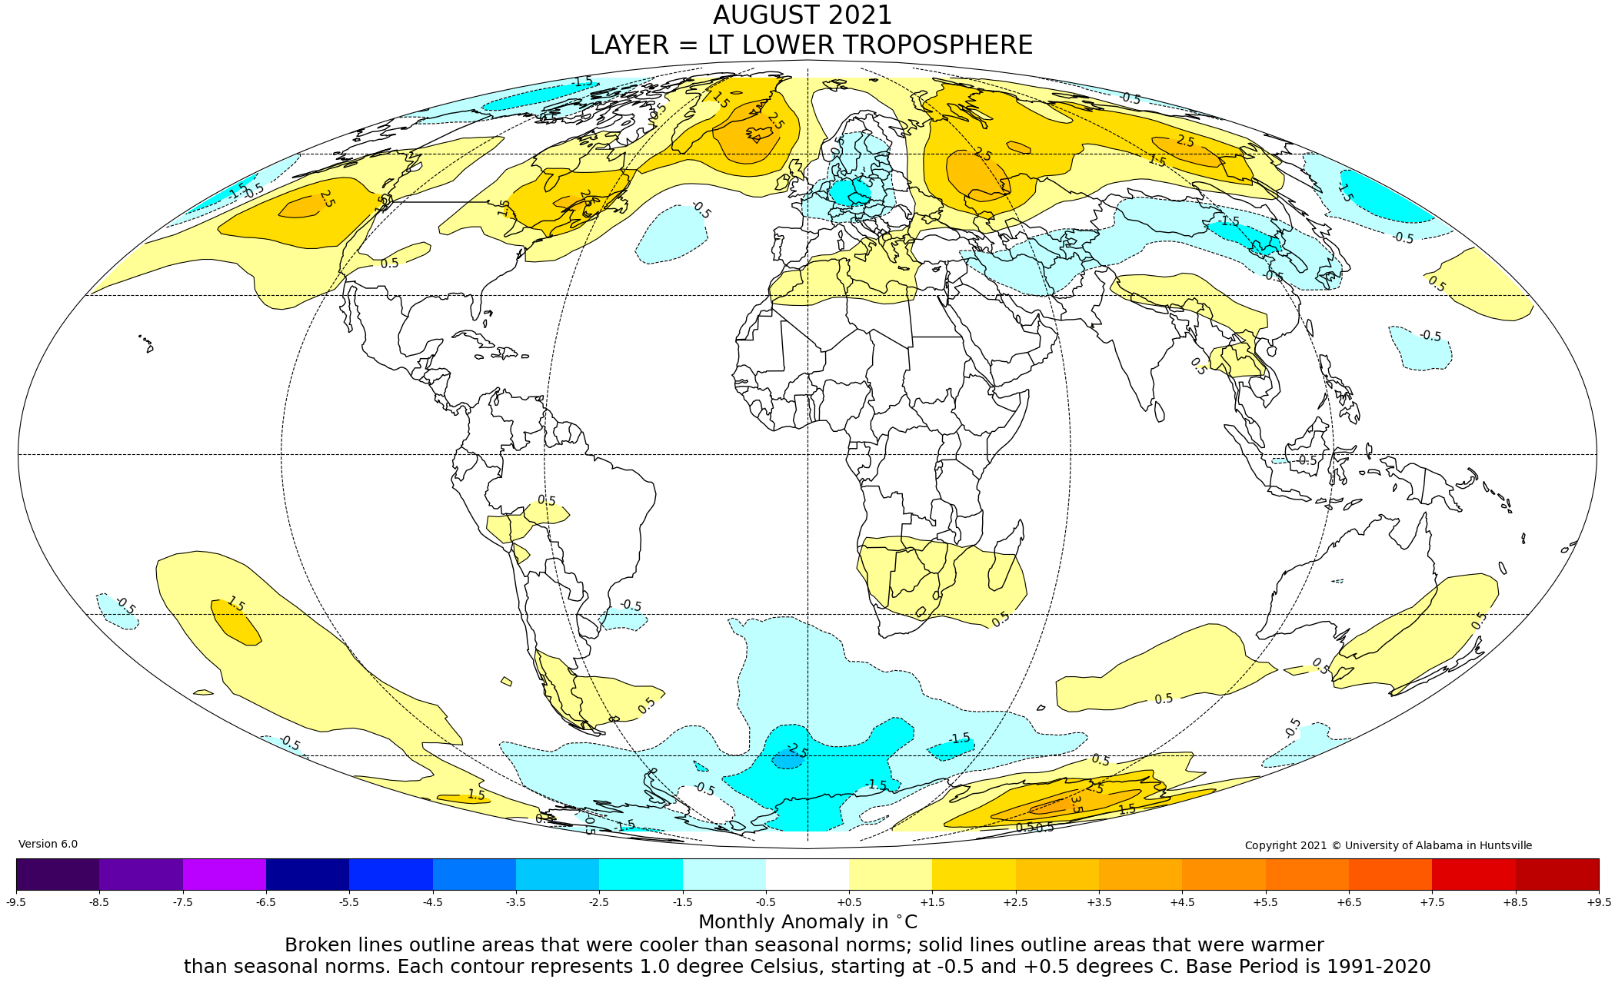
Figure. Lower tropospheric temperature anomalies for July 2021

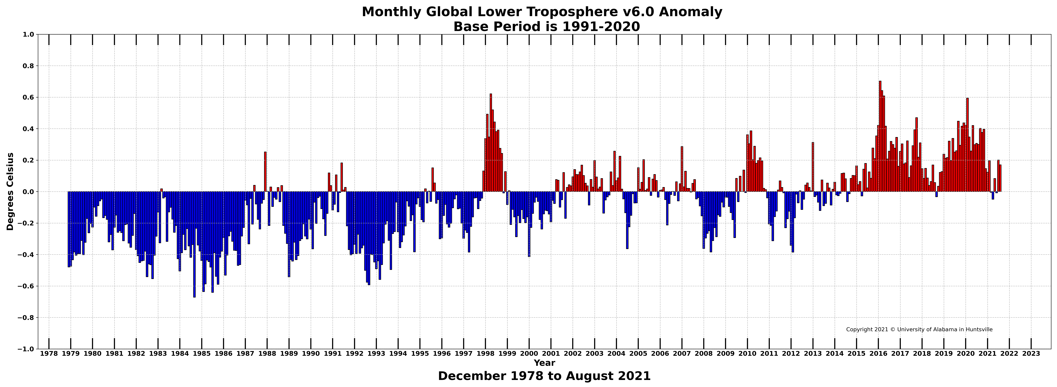

Figure. Bar chart of global monthly lower tropospheric temperature anomalies.

